THE OBSERVER DESIGN PATTERN AND THE MAINTENANCE OF CONSISTENCY CONSTRAINTS IN AN OBJECT-ORIENTED DATABASE

by
Mark J. Tseytlin

A THESIS SUBMITTED IN PARTIAL FULFILLMENT OF THE REQUIREMENTS FOR THE DEGREE OF MASTER OF SCIENCE
IN
COMPUTER SCIENCE

UNIVERSITY OF RHODE ISLAND
2002
MASTER OF SCIENCE THESIS
by Mark J. Tseytlin

APPROVED:

Thesis Committee:
Major Professor ______________________________

______________________________

______________________________

Dean of the Graduate School ______________________________

UNIVERSITY OF RHODE ISLAND
2002

Abstract
Throughout 1990's the trend in database theory was towards total object orientation [WK95]. Therefore, many experimental prototypes of Object Oriented Database (OODB) systems have been created. A partial list of such OODB's include OPENOODB by Texas Instruments (TI), IRIS by Hawlett-Packard (HP), and OPAL (included into Facets) by GemStone Systems [EN00]. However, totally object oriented systems were not as robust as relational systems. Currently, this is still the case. A common side effect of partitioning a system into a collection of cooperating object-oriented classes is the need to maintain consistency between related objects [GHJVB95]. A database system uses a set of rules called integrity or consistency constraints to maintain uniformity among objects. These constraints govern the procedural actions needed to maintain consistency in the database.

The observer design pattern [GHJVB95] is a software design pattern that creates a new outlook on the implementation of actions to maintain consistency constraints in object-oriented systems. It separates the actual data storage and manipulation (implemented in subject objects) from automatic notification and update of dependent objects (implemented as observer objects) by use of a one-to-many dependency between objects in the system. This allows high level of abstraction on each end because both subject and observer objects [GHJVB95] are independent from each other.

The objective of this study is to implement a database system that illustrates the concept of the observer pattern. In particular it focuses on the application of the concepts of the observer pattern to a concrete database system that is kept as object-oriented as possible.

The Family Tree Database (FTDB) is a concrete database system implemented to illustrate the concepts of the observer pattern. This system uses the “observer query the subject” observer design pattern strategy to maintain consistency within the database.

Acknowledgements

I gratefully acknowledge the help and advice of my major professor, Dr. Joan Peckham, and fellow University of Rhode Island professors, Dr. Lisa DiPippo and Dr. Scott Lloyd, who spent time reviewing and criticizing this thesis. I would like to thank Dr. Laura Beauvais for chairing my defense committee. Also I would like to acknowledge and thank the Raytheon Company and the General Dynamics engineers that reviewed my work and provided constructive criticism and offered suggestions. And finally would like to extend a special thanks to professor Dr. Sunjiv Dugal for teaching me how to think "out of the box" and take creative approaches to solving every day problems.
Table of COntents

Abstract ii
Acknowledgements iv
LIST OF TABLES viii
LIST OF FIGURES ix
1. History and Introduction 1
1.1 History of Database Design 1
1.2 Evolution of Data Models 3
1.3 Introduction to OO Design Patterns 14
1.4 The Observer design pattern 16
1.4.1 Introduction to the Observer design pattern 16
1.4.2 Observer design pattern and database design 20
1.5 Introduction to JAVA language 22
1.5.1 History of JAVA 22
1.5.2 Useful features of JAVA for OO database design 24
1.6 Statement of the thesis objectives 30
2. High Level Overview of FTDB Model 32
2.1 The overall database system 32
2.2 The Person Data Entry Form 35
2.3 The People Data Storage and Manipulation 37
2.4 The Family Tree Graphical Interface 39
2.5 The Relationship Data Storage and Manipulation 42
3. Highlights in Design of the FTDB Model 45
3.1 The FTDB and the Observer Pattern 45
3.2 Relationship consistency checking 52
3.3 The FTDB and Object Oriented Reuse 59
4. Examples of FTDB System operations 65
4.1 PDEF HMI 65
4.2 FTGI HMI 70
5. Summary 77
6. Future Work 81
6.1 From JAVA based PDEF to COTS PDEF 81
6.2 Automatic generation of existence rules and relationship types 84
6.2.1 Further Abstraction of the RDSAM Object Group 84
6.2.2 Automatic Generation of Relationship Types and Existence Rules 87
6.3 Other Enhancements 93
Referenced and Applicable documents 94
Appendix-A Acronyms and Glossary 97
Appendix-B Data Dictionary 100
Appendix-C Relationship Existence Rules 103
Appendix-D FTDB System Code 104
Bibliography 107

LIST OF TABLES

Table 3.2-1 The relationships and the <rel_name_list> classes 53
Table 3.2-2 Husband-Wife Relationship Existence Rules 54
Table 3.2-3 HWL Consistency Search Results 57
Table 4.1-1 DOB Standard 67
Table 5- 1 Thesis Objective vs. Achivement Summary Table 77
Table 6.2.2-1 Half_Brother – Half_Sister Relationship Existence Rules 90
Table 6.3-1 Other Enhancementns 93
Table A-1 List of Acronyms and Abbreviations 97
Table A- 2 Glossary 98
Table A-3 Specialized Notation 98
Table B- 1 Message Definitions 100
Table B- 2 Input types and their standards 102
Table C-1 Relationship Existence Rules 103
Table D- 1 Classes implementing FTDB System 104

LIST OF FIGURES

Figure 1.1-1 A Typical Database System 1
Figure 1.2-1 Evolution of Data Models 3
Figure 1.2- 2 Example of a Flat File 4
Figure 1.2-3 Hierarchical Data Model 6
Figure 1.2- 4 Network Data Model 7
Figure 1.2-5 Hierarchical Network Data Model 8
Figure 1.2-6 Relational Table 9
Figure 1.2- 7 Relational Data Model 10
Figure 1.2- 8 Example of violation of 1 to 1 constraint in a semantic data model 11
Figure 1.4.1- 1 Example of Subject - Observers model [GHJVB95] 17
Figure 1.4.2- 1 Customer window observes a customer 20
Figure 1.5.2- 1 Example of a JAVA class 24
Figure 1.5.2- 2 Example of a linked list implementation in JAVA 25
Figure 1.5.2- 3 Example of substitute for multiple inheritance 27
Figure 1.5.2- 4 Thread diagram 28
Figure 2.1-1 Major components of the Family Tree Database System 34
Figure 2.2-1 Person Data Entry Form 35
Figure 2.2-2 The Person Data Entry Object Group 36
Figure 2.3-1 People Data Storage and Manipulation Object Group 37
Figure 2.4-1 Family Tree Graphical Interface Object Group 39
Figure 2.4- 2 Family Tree Graphical Interface 40
Figure 3.1-1 FTGI Class Interface Diagram 47
Figure 3.1-2 RDSAM Class Interface Diagram 48
Figure 3.1-3 The Drawing Menu 50
Figure 3.2-1 Marriage relationship consistency checking roadmap 55
Figure 3.2-2 PL Class Interface Diagram 55
Figure 3.2-3 HWL Class Interface Diagram 56
Figure 3.3-1 Circle Class/ End User Interaction 59
Figure 3.3-2 InsertCircle () method 61
Figure 3.3-3 DM/arrowType Class Subgroup / End User Interaction 61
Figure 3.3-4 The Drawing Menu 62
Figure 3.3-5 MW Class / End User Interaction 63
Figure 4.1-1 The last record from the input file 66
Figure 4.1-2.2 Incorrect DOB field update 68
Figure 4.1-2.1 Correct DOB field update 68
Figure 4.1-3.2 Error on the input 69
Figure 4.1-3.1 Valid new record 69
Figure 4.2-1 “Observer query the subject” observer pattern strategy 72
Figure 4.2-2.1 The initial set of person records 73
Figure 4.2-3 The results of unsuccessful attempt to create Husband(Jorn)-Wife(Mar) relationship 76
Figure 6.1-1 Person Data Entry Form 82
Figure 6.2.1-1 Restructured RDSAM Object Group 86
Figure 6.2.1-1 Restructured RDSAM Object Group 87
Figure 6.2.2-2 Relationship validity checking/ relationship type creation process 88
Figure 6.2.2-3 The Relationship Map for (P₁, P₂) 89
Figure 6.2.2-4 New DM Relationship Choice 91

1. History and Introduction

1.1 History of Database Design
A database is a collection of related data or known facts that can be recorded and that have implicit meaning [EN94]. A typical database management system consists of a Data Modeling Language (DML), a Database Management System (DBMS), and a Human-Machine Interface (HMI), as depicted in Figure 1.1-1.

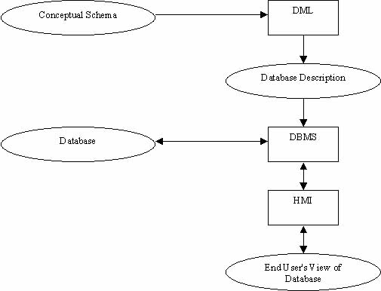
Figure 1.1-1 A Typical Database System

Database systems are computerized systems in which the interpretation and storage of information are of primary importance [MD92]. Typically a database designer creates a database description based on their conceptual view of the system. This conceptual view is also known as a conceptual schema. This logical database description is implemented with the DML specific to that DBMS. This conceptual schema is the input to the DBMS. The DBMS is a software package that supports the implementation of databases and performs operations on the data that is stored in the databases. These operations include storage of the data in a database, search and manipulation of stored data, and display/receipt of old/new data from the end user through the HMI. The characteristics of these operations are directly dependent on the data model used as the conceptual guideline for the implementation of the DBMS. Therefore, the characteristics of a data model are of utmost importance in the database design field. Hence, there has been rapid evolution of data models over the years.

1.2 Evolution of Data Models
There have been many different data models introduced over the years (see Figure 2.1-1) [EN00]. In this thesis, the term data model refers to a model used for the design of database schemas.
Variable length records and files
Flat files
Relational data model
Object-relational data model
Semantic data models
Object-oriented data model
Hierarchical data model
Network data model
Figure 1.2-1 Evolution of Data Models
For many years, data models were not record-oriented. Therefore, the data was not stored in rows and columns of tables as it usually is today. This was due to the limited capabilities of the computer technology. The main obstacles to progress were the slow processor speeds, the limited memory sizes, and the small storage capabilities of earlier computers.

Variable length records and files first appeared with the introduction of sequential access magnetic tape media and were utilized in business applications. In this format, individual files were designed with fixed length records within each file. However, each file could have records sized differently than the size of records in other files. With the advent of non-sequential disk storage technology, random processing strategies were introduced [MM92]. That meant that the software did not have to search the file from top to bottom for a particular record. In conjunction with these strategies came the use of indexes. These indexes were used for direct access of records from the storage media. Their application was limited to flat files containing fixed length records (see Figure 1.2-2). The unfortunate drawback of this approach was that flat files could not have repeating groups of information [DK97]. This approach assured uniform size of the records, but imposed a severe constraint on the natural structuring of data in some applications. For example, we would not be able to store student transcripts in the same file with the student personal information due to the aforementioned technical constraint.
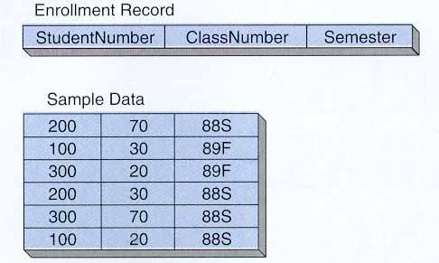
Figure 1.2- 2 Example of a Flat File
Later, indexing techniques were introduced and combined with early multi-format record file processing concepts [MM92]. These new techniques introduced the use of pointers and allowed the design of more complex data models. These new data models were hierarchical, network, and, later, relational models.

The hierarchical data model was created in the 1960's. It was based on well-defined data structures that were connected by links in a tree-like manner (see Figure 1.2-3). This invention was the first step towards the implementation of inheritance. In this model each data-structure contains data about a single entity, family, or group [MM92]. This information is relatively uniform in nature and an entity has few distinct subtypes. The primary access to the structure is through the primary key, usually located at the root of the hierarchy. Inside such a structure, root level segments are related only to the segments directly dependent to them. The access path to the segments beneath the root segment had to include all immediate hierarchic predecessors. For example, in order to get to segment F one would have to traverse the structure from A to C and then to F (see figure 1.2-3). Note that E cannot directly reference F because communication is only allowed between a parent and a child, but not between siblings. Each system has rich descriptive attributes occurring in multiples. Entity occurrences can be processed one at a time.

Root A,
Parent of B, C, G
Child C of A,
Parent of D, E, F
Child G of A
Child B of A
Child E of C
Child F of C
Child D of C
Structure entry point
Figure 1.2-3 Hierarchical Data Model
On the other hand, the network data model, also introduced in the1960’s-70’s, had a very flat structure. In other words it was composed of well-defined data structures that were connected at one level. Such architecture is known is a flat hierarchy. Most networks do not have any implicit hierarchical relationship between the segment types and in many cases, no implicit structure at all. The record types are seemingly placed at random [MM92]. Such data structures are used to hold data about multiple entries, families, or groups connected in complex relationships. The systems can be accessed through the identifiers of entities, as well as through their relationships with other entities (see figure 1.2-4).
Member F
Entry point
Set D-F
Set D-B
Owner D
Set A-B
Owner A
Member B
Set C-B
Set E-F
Set E-C
Owner C
Owner E
Entry point
Entry point
Entry point
Different groups in the network model are engaged in pair-wise relationships in which one record is the owner (parent) of the set and the other one is the member (child). Each member of the set can relate to another record in another pair-wise relationship as a parent or as a child. The most important rule of this model is that the universe (the DBMS) has to see all the data entities and their relationships in order to process transactions aimed at many interrelated entities [MM92]. There are very few hierarchic relationships between entities in a network data model. Even though it is possible to implement a hierarchical network model (see Figure 1.2-5) it is more cumbersome and would defeat the principle of network approach because it would require a single point of entry into the root of the model.
Figure 1.2- 4 Network Data Model

A
D
C
B
I
H
G
F
E
Figure 1.2-5 Hierarchical Network Data Model
The relational data model was not developed until the late 70s- early 80s. It was the first to introduce the concept of data independence [EN00]. In other words, it was the first to exemplify a model and a query language in which the layout of the data on a disk drive was not determined by the data model. The model was implemented by employment of one level of abstraction with a mapping from the database schema to the physical layout of the data. The flat file structure is still used. However, data is organized into normalized relations to prevent data-anomalies caused by manipulation of the data. These relations or tables (see Figure 1.2-6) have three specific properties. First each relation (cell) of the table can only have a singular value. Each attribute (column) can only contain data from the same domain. Finally, no two tuples (rows) can contain identical information. Each tuple contains a logical key or index that makes it unique.
For example in Figure 1.2-6, "Account Number" serves as the key because it is unique in each record. Unlike the hierarchical and network data models, databases based on the relational model use foreign keys instead of physical links for data relations [JO98]. This allows linking of data between different tables and even between different databases. Figure 1.2-7 shows that a foreign key is the primary key of a data structure (table or database) that is included into another data structure in order to connect the two with a data relation instead of a pointer. The "Department Number" is a primary key in the data structure that contains all departments. It is also included in the data structure that contains all students assigned to the various departments in order to create a relation between each student and each department. Nevertheless, the first attempt to better represent real world objects in a database system did not come about until the inception of semantic models [PM88].
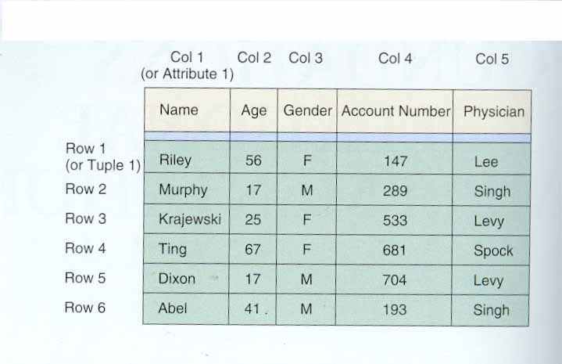
Figure 1.2-6 Relational Table

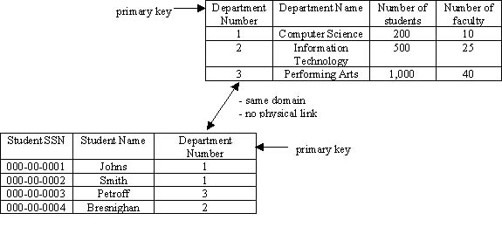
Figure 1.2- 7 Relational Data Model

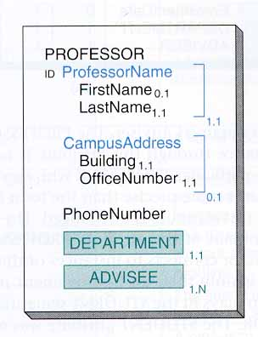
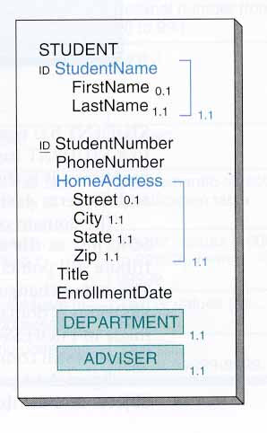
Semantic data models brought several additional capabilities in relationship modeling. The first concept is generalization. Generalization is a technique for describing a real world object by properties that are common to real world objects of the same general class. For example, a square can be represented with sides and angles -- properties that are universal among all the rectangular shapes. The second is aggregation. Aggregation is a technique for describing a real world object as a composition of sub-objects. Notwithstanding the fact that the concept of generalization is very close to the concept of data abstraction, the semantic model does not support abstract classes. Generalization is a concept frequently used in object-oriented programming languages, in which a generalized class is used to typify the structure and behavior of a set of subclasses. This super class serves as a model for the subclass only and is never instantiated in the program. Also, complex constraints that are common to real world objects are not supported either. For example, active
database constraints are not supported. Semantic models permit expression of constraints such as cardinality constraints. However, this data model does not permit the expression of the means by which constraints are to be maintained. If we are to create a 1 to 1 Advisor-Advisee relationship between two objects (Professor and Student) (see Figure 1.2-8) [DK97], the constraint may eventually be violated if the user associates an object of type Student with two objects of type Professor. If the dotted, or second, relationship is created, the system could respond in an unexpected way. Therefore, it was not until the inception of active databases that these issues were addressed. Active models support constraints with active rules to express the procedural means for maintaining consistency [PMD95].
Figure 1.2- 8 Example of violation of 1 to 1 constraint in a semantic data model

The design of these database systems very quickly became tightly coupled with the Object-Oriented (OO) paradigm. New OO representation is more appropriate for the task because it encapsulates behavior and data structure into objects. This allows a more complete representation of real world objects in computing [JO98].

The notion of encapsulation allows the incorporation of methods representing behavior of a real world object into classes that define such objects. The concepts of inheritance and specialization are natural to this data model. Because of specialization, database constraints can be defined at the highest possible level – the abstract class level. Unfortunately, it is very difficult to keep a collection of related objects consistent as the states of different objects change. Furthermore, even now some OO systems lack or are still evolving to include many of the major database features existent in RDBs (Relational Databases), such as a full nonprocedural query language, metadata management, views and authorization [WK95]. There have been a few attempts to fix the above-mentioned problems. One of the approaches is to extend the object-oriented model with a semantic model. The SORAC (Semantic Object Relationships And Constraints) data model extends the object-oriented data model to allow the relationships between objects to be modeled within the object-oriented paradigm [MD92].

The SORAC model and the results of related research raise some questions and uncover some problems. For example, one of the topics that was not addressed in the SORAC data model is the issue of insertion constraints to define the required relationships between objects [MD92]. In an object-oriented database system, insertion is the creation of a new object. Consequently, insertion constraints are the rules that govern the creation process in order to keep the database consistent. The main logical dilemma in the SORAC project with regard to insertion constraints was whether relationships between classes define requirements on all instances of related classes, or does the relationship need to be connected to an instance before the relationship constraints hold? [MD92] This and other problems were aggravated by the fact that the programming languages used to implement these models were not totally object oriented. There was no mechanism to abstract these design and implementation issues. Consequently, most of the designs were very specialized and non-reusable. However, over the years it was found that all of these designs followed some recurring design patterns.

1.3 Introduction to OO Design Patterns
Over the years it was discovered that because each object is believed to represent a real world entity many programmers mistakenly develop very specialized and therefore non-reusable implementations. That is, many object-oriented systems bear the cost of being implemented as a set of concrete classes. Thus, the OODMs (Object-Oriented Data Models) have not yet developed a coherent paradigm in dealing with consistency due to the ad-hoc nature of their implementations [PMD95]. However, many expert OO programmers realize that designs should be specific enough to the problem at hand, but general enough to address future problems and requirements [GHJVB95]. In order to eliminate redesign, or significantly minimize it, many experts reuse previously written code for new projects, thus justifying the primary purpose for existence of the OO design. This reuse is possible because most OO systems employ similar classes and communicating objects arranged in reoccurring patterns.

There are many of these patterns, but all of them are categorized by four essential elements: pattern name, problem, solution, and consequences [GHJVB95]. The pattern name is a "handle" describing a design pattern in context of the concept that the pattern represents. The problem element suggests when the pattern should be applied. Its solution is a scheme of the design with relationships, responsibilities and collaborations. The consequences represent the pros and cons of applying the pattern to the design. In order to determine which abstract pattern is to be used as a basis for implementation of a concrete application, available patterns should be matched to the task at hand. The main questions that get answered while matching a design pattern to the concrete design problem are:
(a) What does the design pattern do?
(b) What are the situations in which this design pattern is applicable for use?
(c) Which classes are in the design and how do they collaborate to keep the
design consistent?
(d) How does the pattern support its objectives and what are the trade-offs and results of using the pattern [GHJVB95].
Essentially, by answering the first question we determine the purpose of each design pattern as we go through them in search of best pattern for our use. Once we select a pattern, we must do some investigation to determine if the selected pattern is consistent with the purpose of the target software. If the selected pattern is applicable, then it should be determined whether the number and type of classes necessary for implementation of the pattern are reasonable for the implementation at hand. Also, at this stage of analysis we should determine if these classes contain parameters and functionality required for proper development of a concrete software application. Finally, we should analyze the scope of the required operations, as well as the system and software requirements necessary to support these operations. In this study, we use the observer design pattern as the conceptual schema. This pattern is used in the object-oriented design and implementation environment and captures a dynamic design that accomplishes much that is similar to the spirit of the active database design.

1.4 The Observer design pattern

1.4.1 Introduction to the Observer design pattern
The observer design pattern, as any other pattern can be described using four essential elements: pattern name, problem, solution, and consequences. This pattern is named Observer because it is intended to define a one-to-many dependency between the subject object and its dependent observers so that when the subject object changes state, all its dependents are notified and updated automatically. This is a kind of “active” behavior among the objects.

The pattern is applied to design and development problems where there is a need to maintain consistency between related objects in an OO system partitioned into a collection of cooperating classes. Every time an object changes its state in such environment it affects the states of many other objects in the same system. However, unless the objects are tightly coupled this object does not have any knowledge of how many and which objects need to change their states to preserve consistency. Consistency, however, should not be achieved by making classes tightly coupled because such an approach would diminish reusability of the system. Therefore, we need to use an approach where an object is able to notify other objects of any changes without making assumption about who these objects are [GHJVB95].

The observer pattern solves the problem of tight coupling by separating the user interface object from the underlying application data. For example, in Figure 1.4-1 we can clearly see that the subject – the data object – is completely independent from the observers – the user interface objects. Furthermore, each observer object is completely independent from other observers. Here each object can be reused independently. However, due to interaction with the subject each observer behaves as if it communicated with other observer objects directly.
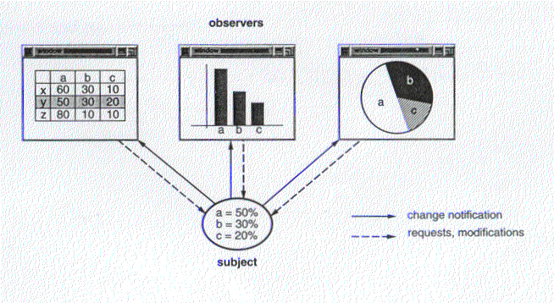As the subject object changes its state due to interaction with one of the observer objects or other external stimuli (i.e., sensors or time) it makes sure that change is valid and propagates the change to all its dependant observers. For example, if one of the observers in Figure 1.4-1 changes its state through modification by an end user, it sends a request to the data object. This request contains the announcement that the change took place as well as the information about what was changed. The subject makes sure that the change is not going to violate internal consistency of the system and notifies other dependant observers. Then it sends an "OK" to the observer that initiated the change of state, allowing the observer to finalize its own change of state.
Figure 1.4.1- Example of Subject - Observers model [GHJVB95]
The subject object notifies its dependents of the change by using "push" or "pull" model. In the push model the subject sends observers detailed information about the change, whether they want it or not. In the pull model the subject sends nothing, but the most minimal notification, and observers ask for detailed explicitly thereafter [GHJVB95]. The system can support many subject objects to make sure that it does not get bogged down with all the updates to the observers. Another technique used to optimize the performance of the observer-pattern-based system is to specify modifications of interest explicitly [GHJVB95]. This technique is based on allowing observers to register with subjects for specific events, that are of interest to each observer. So, when such an event occurs and only in this case, an observer gets a change of state notification from the subject.

The obvious consequence of this technique is that each observer receives only the information that it requires and only when this information is needed. The consequence of such implementation is a greater degree of specialization leading to a more tightly coupled system. However, without additional protocol to help observers discover what changed in the subject, they may be forced to work extra hard to deduce the changes [GHJVB95]. Since observers have no knowledge of each other, they are blind to the cost associated with the changes in the subject. So, if update criteria are not well defined, then any change could lead to a series of spurious updates [GHJVB95].

This could be especially costly in a database system. Thus, it is very important to define the system well during design. The next section gives an example of a well thought out database system that uses the observer pattern as the schema for its implementation.

1.4.2 Observer design pattern and database design

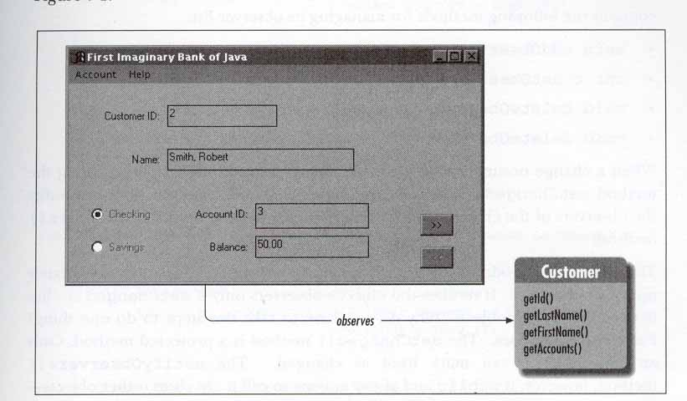
George Rees [GR97] introduced one of the first implementations that used the observer design pattern for database design. In his book “Database programming with JDBC and JAVA”, he implemented a traditional banking application (see Figure 1.4-2) using java.util.Observer and java.util.Observable classes. In this implementation, the customer windows are the observers. They are created on drawing panels and employ widgets (imbedded tools) within a JAVA panel to directly map the contents of the Customer business object to the screen [GR97]. The Customer object in this context is designated as observable (the subject in our notation). Any end user can make changes to the information on a customer window. The changes are propagated to the observable object that takes two steps (mark itself as “changed” and notify all observers) to commit any change. At first the Customer object changes its state to allow parameter change to take place. Then it uses the update () provided by java.util.Observer to notify all the observers of the change that took place. The system uses a boolean flag to lock the observable object during the update to prevent changes entered at another Customer window from altering the Customer business object before current update is committed. The success of this study and other database design considerations, mentioned in the next section, led to the selection of JAVA programming language as the DML for this study.
Figure 1.4.2- Customer window observes a customer

1.5 Introduction to JAVA language

1.5.1 History of JAVA
JAVA was conceived as an operating system language for set-top-boxes during the “Green Project” at First Person, Inc. (formerly a part of the SUN Microsystems). James Gosling and Patrick Naughton started off by creating a programming language called Object Application Kernel (OAK) by extending the C++ compiler. However, C++ turned out to be too inflexible for the task, and required the authors to make more extensive changes. When in 1994 “Green Project” was closed by SUN Microsystems, because of poor sales of interactive cable decoders, OAK, now called JAVA, was reoriented toward the World Wide Web (WWW). It is important to note that by mid-1994, the Web was “BIG” [PV96]. However, the browser technology was lacking. Thus, when Gosling and his colleagues decided to create “WebRunner”, a Web browser written in JAVA, the idea was extremely successful. By the fall of 1994 “WebRunner” was released and became the early incarnation of “HotJAVA”, today’s version of a Web browser based on the JAVA language. At this point the JAVA language widely spread around the world and became very popular as a teaching tool. In the past several years, JAVA has replaced C++ in the computer science classrooms of several universities and four-year colleges [CK99]. This and the mass release of the JAVA interpreters by software corporations like Microsoft and Borland gave some people a reason to believe that C++ was dying and that JAVA was the beginning of a new era. This is an era where networks would dominate and every piece of business would be done through the Internet.

From the very beginning, it was obvious that JAVA was more suitable as a tool for the implementation of OO DBMSs than most programming languages [GR97]. This was due to certain features included in JAVA’s makeup at its inception.

1.5.2 Useful features of JAVA for OO database design

JAVA is a totally object oriented language. That is, in JAVA everything is done inside a class or by a call to a method inside a predefined class [GA96]. This is very useful for the purposes of creating a totally object-oriented database. JAVA uses a class construct like the one shown in Figure 1.5.2-1. The sample class can be instantiated through its constructor (sample ()) by a method call from another class. Other methods, operate () for example, can be called by methods from other classes in order to perform some operations on the instances of this.
Figure 1.5.2- 1 Example of a JAVA class
class sample
{
type₁ variable_{s1};
……
type_{n} variable_{sn};

public sample (type₁ argument₁, …, type_{n} argument_{n})
{
this.variable_{s1} = argument₁;
….
this.variable_{sn} = argument₂;
}

public static void operate (String args[])
{
operations………
}
}

Another important feature is that JAVA is free of pointers. For example, in JAVA, objects are passed as arguments directly. The elimination of tedious and error-infested pointer operations makes programming in JAVA easier [CH96]. For example, in Figure 1.5.2-2 we see that representation of elements of the linked list involves objects nested within other objects.
Linked List
head
class Link
{
Object data;
Link next; //pointer to another object in the class
}
tail
NULL
Link
date
next
Link
date
next
Link
date
next
There are no explicit pointers from object to object. This property allows the JAVA Virtual Machine (JVM) to execute JAVA programs on most platforms without reinterpretation (“recompilation”). Therefore, JAVA is a portable programming language [GM99]. The Link is a class. Thus, each instance of “Link” is a separate and distinct object.
Figure 1.5.2- 2 Example of a linked list implementation in JAVA

JAVA does not support separate header files. In other words, everything about a class is contained in a single file. The signature of a method and its implementation appear only in one place. In other words, the implementation of a method must appear simultaneously with its declaration [GA96].

In JAVA, strings are not equivalent to character arrays, as they are in C. JAVA programming language does not support a built-in string type. Instead, the standard JAVA library has a predefined class – String, containing all of the utilities used to operate on the strings of characters [CH96]. The advantage of this representation is that JAVA’s strings cannot be accidentally overwritten as can happen with character arrays in C/C++ [GA96]. This is beneficial for data entry, manipulation, and storage programs like databases because each line is stored as a separate string in a list of strings. Also, JAVA’s string representation saves storage space.

Another aspect of the JAVA language is the lack of multiple inheritance. In other words, no JAVA class can have more than one superclass. This is very useful in a complex object oriented database environment where records are implemented as instances of compound objects. For example, the instance of the Russian_male object inherits basic properties of the male object type (see Figure 1.5.2-3). On the other hand, the white_male object also inherits from the male object. If multiple inheritance is allowed, then the Russian_male object would inherit basic properties of the male object type twice. Instead, of multiple inheritance, JAVA offers interfaces. An interface is a promise that your class will implement certain methods with certain signatures [CH96]. Thus, in order to be able to use the methods of white_male object, we must declare an interface for white male. This promises that any class that implements the white_male interface will contain any methods that need to be used by objects inheriting from the male object. This is not the same as the "IS-A" relationship because the Russian_male object does not inherit from the white_male object. Thus, there is no class/subclass relationship between these entities [EN00].
male object
Russian_male
object
white_male object
white_male interface
basic properties of male object type
basic properties of male object type
ethnic property
ethnic property
Figure 1.5.2- 3 Example of substitute for multiple inheritance

Another JAVA innovation is the support of multithreading. This feature allows running more than one operation at a time. This characteristic is effective when, for instance, two transactions make modifications to the same part of a database from different sites at the same time. In this situation one of the transactions should wait for the other to complete before it can proceed. This is an important accessory for the OO languages because it makes the parallel processing easier to implement and more desirable to use in the concurrent database environment. Concurrency is a key feature of modern database systems [EN00].

As we can see in Figure 1.5.2-4, a long running process can be put to sleep (blocked), which makes it run in the background without taking up the whole CPU. Meanwhile end users can do word-processing in the foreground. Then at a designated moment the blocked threads can be resumed and become runnable again. However, the word processing application will be stopped and killed. In a multi-threaded environment one must be careful of selfish threads, those that do not sleep and therefore, monopolize the system. For example, when two people make modifications to the same part of the database at different sites at the same time, one person should wait for the other person’s transaction to close before he/she can proceed with their process. The person making changes first might take a long time to complete them thus making the second process wait indefinitely. Therefore, one must be careful when programming with threads. This shows that good system code design plays an important role in the correct and consistent implementation of software systems.
new
runnable
blocked
dead
Figure 1.5.2- 4 Thread diagram

1.6 Statement of the thesis objectives
Throughout 1990's the trend in database theory was towards total object orientation [WK95]. Therefore, many experimental prototypes of Object Oriented Database (OODB) systems have been created. A partial list of such OODB's include OPENOODB by Texas Instruments (TI), IRIS by Hawlett-Packard (HP), and OPAL (included into Facets) by GemStone Systems [EN00]. However, totally object oriented systems were not as robust as relational systems. Currently, this is still the case. However, totally object oriented systems, as we have already pointed out above, are not currently as robust as other database systems. A common side effect of partitioning a system into a collection of cooperating object-oriented classes is the need to maintain consistency among related objects [GHJVB95]. One way to manage this need is tointroduce a set of rules called integrity or consistency constraints to maintain uniformity among objects. These constraints govern the procedural actions needed to maintain consistency in such an active database.

The observer design pattern [GHJVB95] is a software design pattern that creates a new outlook on the implementation of actions to maintain consistency constraints in active object-oriented systems. It separates the actual data storage and manipulation (implemented in the subject objects) from automatic notification and update of dependent objects (implemented as observer objects) by use of one-to-many dependencies between objects in the system. This allows a high level of abstraction on either end because both subject and observer objects [GHJVB95] are independent from each other.

The objective of this study is to implement a system that illustrates the concept of the observer pattern. In particular it focuses on the application of the concepts of the observer pattern to a concrete database system that is implemented as object oriented as possible. The observer pattern is used to maintain database consistency. To the best of our knowledge no one has done a study such as this before.

This study is important because it is proving usability and feasibility of the observer pattern by applying it to a simple application. It takes techniques previously used in active OO database systems and explores an alternate approach using the observer pattern.

The database implementation uses the concept of the observer pattern to separate the Human Machine Interface (HMI) part of the system from the data collection/ data manipulation part. This approach allows individualization of parts of the schema, therefore allowing generalization and reuse in further research attempts.

The Family Tree Database (FTDB) created in this thesis uses the data and subset of relationships introduced in [LD97]. The FTDB is implemented using JAVA. The next section of this thesis contains a brief description of this database application.

2. High Level Overview of FTDB Model
The Family Tree Database (FTDB) is a concrete database system implementation that uses concepts of the observer pattern. This system uses the “observer query the subject” observer design pattern strategy (see subsection 3.1 for a detailed example). The design pattern is used to maintain consistency within the database and to separate the Human Machine Interfaces (HMIs) from the data objects.

During the design stage we realized that in order to properly implement database functions, we could not use individual objects to serve as observers and subjects. Instead we combined individual objects into observer and subject object groups. Each group was tasked with particular database functionality. The following subsections give a brief description of these groups and the functionality that they provide.

2.1 The overall database system

The FTDB is implemented as the network of two observer groups and two subject groups (see Figure 2.1-1). The database has two HMIs – one form-based and one graph-based. Both observers and subjects are implemented as completely autonomous sets of classes that correctly implement observer pattern characteristics. The database is known as FTDB because it is used to store people’s family oriented data and to manipulate this data when people’s records are modified, new records are entered, or relationships of various family types are created among distinct people.

The database has the following functionality:
(1) The end user is able to enter information through one of the two HMIs.
(1.1) Person data can be entered via Person Data Entry Form (PDEF). There are two ways to accomplish this. Data can be entered via keyboard or by accessing an input file.
(1.2) Relationships between existing people can be established via the Family Tree Graphical Interface (FTGI). The system supports marriage, ancestry, and sibling relationship groups.
(2) The system checks consistency constraints after any particular family relationship is established. The People Data Storage and Manipulation (PDSAM) module facilitates the age and gender consistency checks. The Relationship Data Storage and Manipulation (RDSAM) module supports consistency checks among existing relationships. Both of these modules are subjects. As such they are responsible for the maintenance of consistency of states of all objects in this system. The database is implemented with one-to-many relationships among all object groups. Therefore, dependent observers are automatically notified of changes and update their states. (Note that in Figure 2.1-1 and later in this document the “↔” stands for two-way communications between two object groups.) The relationships between these object groups are instances of the association abstraction (a concept used to correlate objects from several independent classes) [EN94]. Furthermore, they are instances of the “uses” relationship type.
Observers

Person Data Entry Form
(PDEF)
Family Tree Graphical Interface
(FTGI)

People Data Storage and Manipulation
(PDSAM)

Relationship Data Storage and Manipulation
(RDSAM)
Subjects
Figure 2.1-1 Major components of the Family Tree Database System
The system’s operations always starts from the PDEF object group. This HMI is the gate through which initial information (via person records) is inserted into this database system.

2.2 The Person Data Entry Form

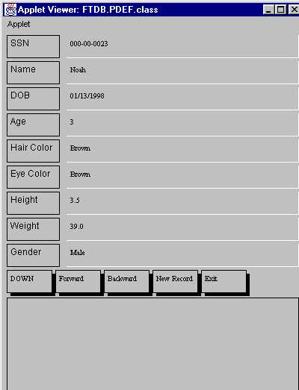
The PDEF is an observer object group that represents a data entry form. It is used to provide the end user with an HMI to input people’s records into the FTDB (see Figure 2.2-1).
Figure 2.2-1 Person Data Entry Form
This information can be in the form of a complete record for a new person, as well as a modification of an existing record. The system does not compute any data. However, it derives certain information based on internal consistency controls as part of checking validity of incoming information.

The Person Data Entry Form (PDEF) object group is comprised of four objects. The main object, which gives its name to the group, is the PDEF object. This object group also contains three utility objects: the field object, the button object, and the Message Window (MW) object (see Figure 2.2-2). The field object is used to represent fields that appear in the data entry form. Each field is a text field that is sensitive to mouse clicks and keystrokes. The end user uses these text fields to enter person information into the database. The button object is used to represent the buttons on the PDEF HMI. The buttons provide form-like functionality to this interface. They allow receipt of information from an input file, browsing between records, and initial creation of a record. The “Exit” button is used to close the system. The MW object is used for display of different messages received from PDSAM object group to the end user based on his/her actions.
Person Data Entry Form
field
button
Message Window
Figure 2.2-2 The Person Data Entry Object Group

2.3 The People Data Storage and Manipulation

PDSAM is a subject object group (see Figure 2.3-1). It is used to facilitate the storage of people data entered via PDEF interface. It is also used to check consistency between the observers and to propagate changes generated in one observer to the other observers. It serves as a view-port among the observer object groups, and RDSAM subject object group. It is implemented as the network of objects representing an array of real world people. This object group is responsible for consistency checks of all information entered through PDEF HMI. See Section 4 of this thesis for a brief example of one such check. Our Project Specification [MT200] contains detailed explanations of all consistency checks. Also, this object group is responsible for Age and Gender consistency checks based on the changes proposed through the other HMI interface (FTGI interface). Finally, the PDSAM object group is responsible for storage of consistent person information and retrieval of this data from storage upon request from one of the interfaces.
universalColor
hairColor
eyeColor
Gender
Person
People Data Storage and Manipulation
People List
myUtilities
Figure 2.3-1 People Data Storage and Manipulation Object Group
Note that in Figure 2.3-1 and in the rest of this document the “ “ indicates the aggregation relation “has-part” and the “ “ indicates “IS-A” relation.

As we mentioned above Person, Gender, hairColor, and eyeColor objects jointly represent a real world person. Both Hair Color and Eye Color objects inherit basic color properties from the universalColor object. People List (PL) object contains a People_List in which instances of the Person object are stored. Both myUtilitites and PL objects are used to check consistency of information entered through PDEF and FTGI interfaces. For example, myUtilities object verifies that a new SSN entered by the end user is of the standard “xxx-xx-xxxx” type, where each “x” is of type “int”.

2.4 The Family Tree Graphical Interface

The Family Tree Graphical Interface (FTGI) is an observer object group (see Figure 2.4-1).
Drawing Menu
Circle List
Line
Circle
Message Window
arrowType
Family Tree Graphical Interface
Figure 2.4-1 Family Tree Graphical Interface Object Group
This interface, like all observers is not specific. It can facilitate any tree or a graph made out of circles and directed lines. In this project, it is used to create relationships between existing instances of the Person object (see Figure 2.4-2). There are two types of Person object: “Male” and “Female”. The instances of “Male” persons are indicated by blue background and “Female” persons are indicated by pink background.

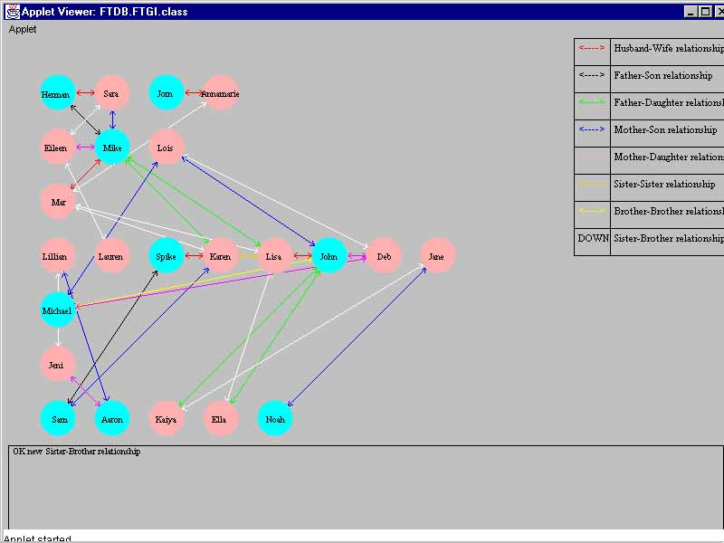
The FTGI object serves as a view-port between the end user and the subject objects PDSAM and RDSAM. The other objects in the group are utility type items used to populate the interface with information presented by graphics and messages. The Circle object is used to represent the above mentioned “Male” and “Female” persons. Each Circle is instantiated with a label (person’s name) a color (based on the person’s gender) and a set of coordinates (based on the person’s age group). All circles are kept in the Circle_List. This list is kept and manipulated by the Circle List (CL) object. This object is responsible for display of all the circles on the FTGI. The display is updated with every mouse click.
Figure 2.4- 2 Family Tree Graphical Interface
There are several types of mouse clicks allowed. The first is a mouse click anywhere on the HMI. Every time such mouse click is made, the display is updated and interface operations can continue. Another type of mouse click is a button click. The Drawing Menu (DM) and arrowType objects are jointly responsible for display of the Drawing Menu choices and functionality of the buttons located on the menu. Each button represents a relationship type. When a button is clicked the interface expects the end user to create a relationship between two people. Each relationship is implemented as an object. See Figure 3.1-3 in Subsection 3.1 for explanations of the significance of different colors of the directed lines representing these relationships on the FTGI.

A third type of a mouse click is used to create a relationship. It involves the end user clicking on two circles in order to connect them with a line of the color representing the relationship selected. After such connection is made, the information about the two people is packaged and passed to the RDSAM object group for consistency checking. After consistency checking is completed, its result (OK update or ERROR violated constraint(s)) is displayed on the bottom of the FTGI by the MW object, the selected button is desensitized, and the relationship is either stored by the system or discarded. If a relationship is not allowed the line that was just created is erased.

2.5 The Relationship Data Storage and Manipulation
The Relationship Data Storage and Manipulation (RDSAM) is a subject object group (see Figure 2.5-1). It is implemented as a network of relationship storage objects, relationship type objects and a view-port object connecting this network to the other object groups in the system. The RDSAM object coordinates consistency checks when they are required. See Subsection 3.2 for examples of one such consistency check. It enforces consistency in the system based on the relationship data that is already contained by the relationship storage objects and by the PDSAM object group. If a new relationship does violate any others, this object allows the relationship to be created and places the relationship in a specific storage class. On the other hand, if the relationship violates some constraints established by other relationships, then the update is denied and the reason for denial is sent to the FTGI observer object group to be displayed in the Message Window on the Graphical Interface.

There are eight relationship storage objects: Husband-Wife List (HWL), Father-Son List (FSL), Father-Daughter List (FDL), Mother-Son List (MSL), Mother-Daughter List (MDL), Sister-Sister List (SSL), Brother-Brother List (BBL), and Sister-Brother List (SBL). Each of these objects contains a linked list in which objects of a specific relationship are stored.

Consistency checking is accomplished based on the relationship consistency rules contained by the relationship objects. There are eight of these objects: Husband-Wife (HW), Father-Son (FS), Father-Daughter (FD), Mother-Son (MS), Mother-Daughter (MD), Sister-Sister (SS), Brother-Brother (BB), and Sister-Brother (SB). These concrete relationship types are part of a more general relationship groups. The HW object is a concrete representation of more abstract Married object. The FS, FD, MS, and MD objects are concrete children of the Ancestor object. Finally, the SS, BB, and SB objects are specific descendants of the more abstract Sibling object. Each of the concrete relationship type objects inherits a set of abstract relationship consistency rules from its respective parent object. Each object is an instance of a specific relationship type. They contain specific relationship type consistency rules. These rules are invoked when consistency type checking is required. If all the rules are satisfied a new instance of a particular relationship type object is created and stored in a linked list contained by the respective relationship data storage object.

The Marriage, Ancestor, and Sibling objects are in turn the children of the Relationship object. This object is even more abstract and contains high-level relationship rules.
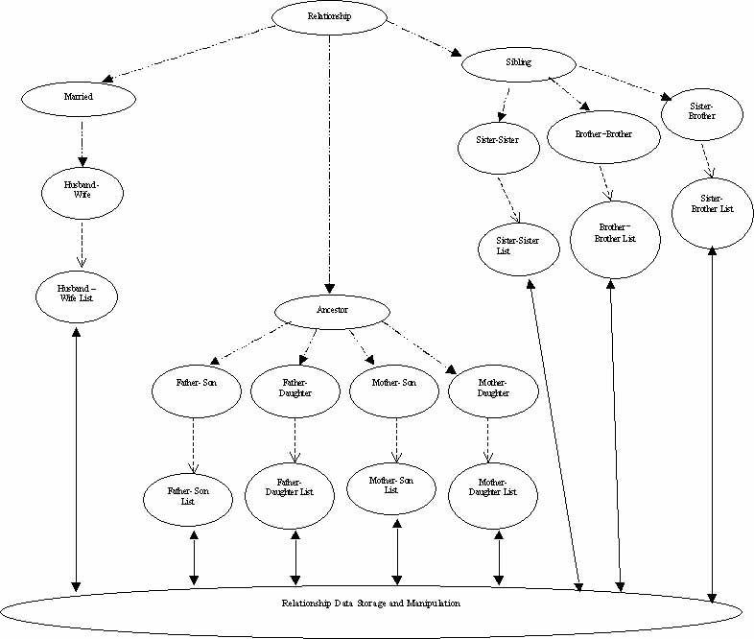
Figure 2.5-1 Relationship Data Storage And Manipulation Object Group

3. Highlights in Design of the FTDB Model
In this section we revisit the concepts outlined in Section 1 and parts of the system described in Section 2. Namely, we use detailed examples of the design and operation of the Family Tree Database (FTDB) system to illustrate the concepts of active databases, the observer pattern, object oriented databases, and the JAVA language presented in Section 1. Recall that the FTDB system is implemented using the observer pattern strategy outlined in Subsection 1.4. This is a suitable approach for an active object oriented database system [GR97]. Also we look at examples of relationship consistency checking in more detail.

As we saw in Section 2, the FTDB system consists of four object groups. In this section we concentrate on parts of the Family Tree Graphical Interface (FTGI) and Relationship Data Storage And Manipulation (RDSAM) object groups, as they are the main focus of this project. The other object groups are in the system for purposes of support and completeness. They are not discussed in this section. See [MT200] for full description of all objects in the four object groups and their capabilities.

3.1 The FTDB and the Observer Pattern
Recall that the observer design pattern is a strategy intended to define a one-to-many relationship among objects so that when one object changes state; all its dependents are notified and updated automatically. The objects in the system designed with the observer pattern are either subjects or observers. The subjects are the data objects and the observers are the user interface objects. There are several types of subject - observer interactions used for implementation of this design pattern [GHJVB95]. In this thesis we use the “observer query the subject” strategy. This is because the end user triggers all FTDB system’s actions through one of the observer object groups.

For example, the FTGI object group is the observer object group. This group maintains one of two HMIs of the FTDB – the Graphical Interface. In this project the interface is used to graphically represent family relationships among person objects contained by the database.

The FTGI object is the main object of this group and is responsible for display and manipulation of the interface based on the end user’s actions and FTDB reactions. The other objects of the group are there to support particular tasks of data display and interface operations. See Appendix D (Table D-1) for the listing and [MT200] detailed description of all objects.

The FTGI class implements the FTGI object (see Figure 3.1-1). This class serves as a view-port between the end user, the PDSAM class and the RDSAM class.
RDSAM subject
object group

PDSAM subject
object group

FTGI observer object group
MW class
PDSAM class
RDSAM class
End User
Circles
Drawing Menu
FTGI class

Figure 3.1-1 FTGI Class Interface Diagram
Recall from Section 2 that PDSAM and RDSAM classes implement the main objects in the two object groups that serve as subjects in the system. The FTGI class also uses an instance of the Message Window (MW) class (described in Section 3.3) to display messages to the end user. Recall from Section 2 that the FTGI observer object group is used to coordinate display and operations of the Drawing Menu and to facilitate display of the circles representing real world people on the FTGI interface. The PDSAM class is used to facilitate the storage of people data entered via PDEF interface, to check consistency between the observers, and to propagate changes generated in one observer to the other observers. It is described in [MT200] in detail. The RDSAM class and its functionality are described in an example appearing later in this section.

The user triggers the observer actions. The FTGI class facilitates their processing. JAVA supports the mouse and keyboard operations by the means of low-level system calls. For example, when the end user clicks on the graphical interface, the FTGI class queries one of the subjects – the PDSAM class [MT200] to find out whether there is any new person information to be displayed to the end user. If there is in fact a new Person object, or if Name or Gender information of existing record was changed, then SSN, Name, Gender, and Age of the new (updated) Person record are received by the FTGI class. The FTGI class, therefore, has permission from the subject to update its state. As a result, FTGI class calculates the coordinates of the circle using the algorithm provided in our Project Specification [MT200].
FTGI observer
object group
PDSAM subject
object group
RDSAM subject
object group
PDSAM class
FTGI class
<rel_name_list> class
RDSAM class
Figure 3.1-2 RDSAM Class Interface Diagram

Next the SSN, Name, Gender, and initial center-point coordinates (initialX, initialY) are used to draw (or redraw) a new circle (an existing circle) on the Family Tree Interface. As soon as this information is displayed the state of the FTGI observer group is once again consistent with the state of the PDSAM subject group.

As another example, the RDSAM object (see Figure 3.1-2) is responsible for coordination of all operations of the RDSAM subject group. The other classes in the group are real world representations of relationship types and their storage facilitators (see [MT200] for details). The RDSAM class implements the RDSAM object. This class is used as an interface between the FTGI class and the classes that operate on linked lists that store information about specific relationship types. Note that “<rel_name_list>” in the Figure 3.1-2 indicates a class that implements such specific relationship list. See section 3.2 for concrete examples.

Recall from Section 2, that the end user can create a relationship between two existing objects by selecting a button marked with a specific directed line from the Drawing Menu depicted in the Figure 3.1-3. The FTGI observer object group displays the relationship to the user. If the attempt to create a line is successful, then in accordance with the concept of the observer pattern, the FTGI propagates indexes of both circles (SSNs) to the RDSAM class (part of the subject object group) for consistency checks.
The RDSAM class receives the information about this proposed relationship. This is essentially an inquiry from the observer object group, which is trying to change its state. The specific information is comprised of the SSNs of the two people in the proposed relationship and the type of line chosen from the Drawing Menu to represent this relationship. Based on the type of line chosen by the end user, the RDSAM class makes a decision identifying the relationship.
Husband-Wife relationships

Father –Son relationship

Father-Daughter relationship

Mother-Son relationship

Mother-Daughter relationship

Sister-Sister relationship

Brother-Brother relationship

Sister-Brother relationship
Figure 3.1-3 The Drawing Menu

The RDSAM class passes this information to the appropriate <rel_name_list> class for a consistency check among relationships of that type already contained by the linked list (see FTDB code for implementation). The RDSAM class follows the existence-requirements table to check all the rules that apply to this relationship’s successful insertion into the database.

After all consistency checks are completed the RDSAM class informs the FTGI class with an “OK new <rel_name> relationship” message meaning that the relationship is consistent with the database. Here, the “<rel_name>” stands for relationship type. If, however, at least one of the rules required for this relationship to be committed is not satisfied, then the RDSAM class passes the “ERROR: (List_Of_Failed_Rules)“ message (where the List_Of_Rules contains the rules that were not satisfied) to the FTGI class indicating that the relationship was notcommitted.

The FTGI class propagates this message to the MW class for display. If the new relationship violates previous constraints, then there is no change in state. Therefore, the tree is not updated. The FTGI erases the newly created relationship. The “ERROR: (List_Of_Failed_Rules) “, or “ERROR: DUPLICATE <rel_name>” message received by FTGI class from the RDSAM class is passed to MW class to be displayed to the end user.

3.2 Relationship consistency checking
In the FTDB system, relationship integrity checking is accomplished by using relationship existence rules as a roadmap. These existence rules are defined inside individual relationship-type objects. The FTGI class uses these rules to perform the work triggered by the end user’s interaction with the FTGI HMI.

Recall from Section 2 that the system supports three general relationship groups: Married, Ancestor, and Sibling. These relationship groups are further broken down into specific relationship types. For example, the Ancestor relationship group contains four relationship types: Father-Son, Father-Daughter, Mother-Son, and Mother-Daughter. Each relationship type has two classes associated with it. One class implements the relationship object and the other performs consistency checks and manipulates the data. For example, the HW class implements the Husband-Wife relationship and its instances are stored in the Husband_Wife_List linked list implemented in the HWL class.

In the previous section we saw how the FTGI object group captures the information entered by the end user and propagates it to the RDSAM object group. As we mentioned earlier, the RDSAM class makes a judgment about the type of proposed relationship based on the type of the line selected by the end user on the Drawing Menu. The RDSAM class passes this information to the appropriate <rel_name_list> class to assure consistency with relationships of that type already contained by the system (see Figure 3.1-2). Table 3.2-1 contains specific relationships and <rel_name_list> classes that store these relationships. Ultimately, these classes are responsible for a duplicate-free database system. Note that “P” in notation stands for “person”.
Table 3.2-1 The relationships and the <rel_name_list> classes
Proposed Relationship | Classes responsible for consistency checks
Husband(P₁)-Wife(P₂) | HWL class
Father(P₁)- Son(P₂) | FSL class
Father(P₁)-Daughter(P₂) | FDL class
Mother(P₁)-Son(P₂) | MSL class
Mother(P₁)-Daughter(P₂) | MDL class
Sister(P₁)-Sister(P₂) | SSL class
Brother(P₁)-Brother(P₂) | BBL class
Sister(P₁)-Brother(P₂) | SBL class

The RDSAM class receives a response from the <rel_name_list> class matching the relationship that the end user tried to create. If the relationship is a duplicate of an existing relationship then appropriate error message is displayed and no further processing is necessary. On the other hand, if the proposed relationship is not a duplicate of the already existing one, another consistency search is conducted. The RDSAM class follows the existence rules table to check all the rules that apply to the proposed relationship and make sure that none of them are violated.

For example, in the case of the proposed marriage relationship, existence rules of Table 3.2-2 need to be observed before such a relationship can be committed. These rules determine validity of a real world Husband-Wife relationship.

Table 3.2-2 Husband-Wife Relationship Existence Rules
Rule # | Rule | Consistency Checked by class
1 | Male (P₁) | PL class
2 | Female (P₂) | PL class
3 | Not (Husband-Wife (P₁, P₃)) | HWL class
4 | Not (Husband-Wife (P₃, P₂)) | HWL class
5 | Not (Sister-Brother (P₂, P₁)) | SBL class
6 | Not (Father-Daughter (P₁, P₂)) | FDL class
7 | Not (Mother-Son (P₂, P₁)) | MSL class

The first two rules of the above table are checked using the following method. As we can see in Figure 3.2-1, the SSN of the assumed male or female is sent to the PDSAM class to facilitate a gender consistency check. The PL class (see Figure 3.2-2) performs all consistency checks. Thus, every time the PDSAM class receives a consistency check request from RDSAM class it passes the information to the PL class. The People_List contained by the PL class is referenced with the SSNs of both prospective Husband and Wife to make sure that he is a “Male” and she is a “Female”. After the task is completed the PDSAM class gets the result and passes it back to the FTGI class that originated the request.

The PL class is used to manipulate the People_List. The People_List is a linked list of people’s records. Each record contains a compound Person object.

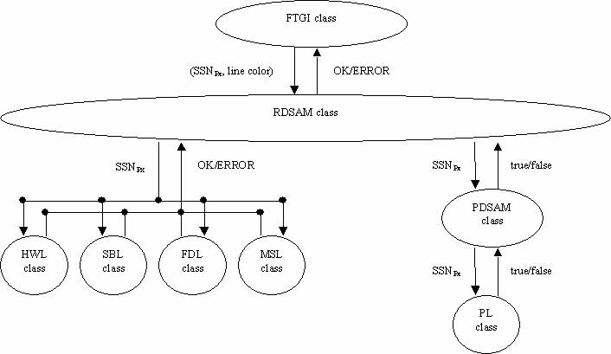
PL class
People_List
PDSAM class
Person class
Figure 3.2-1 Marriage relationship consistency checking roadmap
When, the PL class receives a Gender consistency check request from PDSAM class. The request either Male (P) or Female (P) should be satisfied. If the answer is consistent with what was expected, then either true (P is Male) or true (P is Female) is passed back to the PDSAM class. If, however, the result expected is not consistent with the data contained by the People_List, then the PL class returns false (P is not Male) or false (P is not Female) back to the PDSAM class.
Figure 3.2-2 PL Class Interface Diagram

In order to satisfy Rules 3 and 4, the Husband_Wife_List located in the HWL (see Figure 3.2-3) class is successfully searched with the SSNs of the two people in order to determine that they are not in a Husband-Wife relationship with someone else.
HWL class
Husband_Wife_List
RDSAM class
HW class
Figure 3.2-3 HWL Class Interface Diagram

The HWL class receives relationship information in the form of (P₁, P₂, X) for consistency check. Here the P₁ and P₂ are the SSNs of the people involved in the proposed relationship. The X component is a flag that can be “D” for duplicate-search or “N” for non-duplicate search. If the third parameter is “D”, then the HWL class searches the Husband_Wife_List for an exact duplicate of the relationship. If the third parameter is “N”, then the relationship being checked-out is not the exact relationship that was entered by the end user, but a possible relationship with another person (P₃) that could negate validity of some other relationship.

The HW class returns the results of the search back to the RDSAM class. See Table 3.2-3 for types of searches, findings, and messages returned.

Table 3.2-3 HWL Consistency Search Results
Search type | Finding | Message returned
D | duplicate | ERROR: DUPLICATE Husband(P₁)-Wife(P₂)
N | Husband(P₁)-Wife(P₃) | ERROR: Husband(P₁)-Wife(P₂) RELATIONSHIP NOT (Husband-Wife (P₁, P₃))
N | Husband(P₃)-Wife(P₂) | ERROR: Husband(P₁)-Wife(P₂) RELATIONSHIP NOT (Husband-Wife (P₃, P₂))
D | no duplicates | OK Husband(P₁)-Wife(P₂) DUPLICATE and list of rules from Table 3.2-2
N | no inconsistencies | OK Husband(P₁)-Wife(P₂) NOT (Husband-Wife (P₁, P₂))

Rules five through seven of Table 3.2-2 are verified using a process similar to the one outlined above. Searching the Sister_Brother_List (in SBL class) satisfies the fifth rule. We make certain that prospective partners in marriage are not a Sister and a Brother. As we can see in the Figure 3.2-1, the Father_Daughter_List of FDL class is checked to make sure that the sixth rule is not broken and the Husband is not the Father of the future Wife. In order to do that, the RDSAM class passes SSNs of both people to the FDL class. Finally, the Mother_Son_List of the MSL class is checked to make sure that the future Wife is not in fact the future Husband’s mother, i.e. Rule 7 (see Table 3.2-2).

If all the consistency checks return “OK <rel_name>”, then the relationship is committed. The <rel_name_list> class receives a request from the RDSAM class to store a new relationship in the Rel_Name_List after it has been confirmed as valid. The <rel_name_list> class invokes the <rel_name> class to create a new instance of the <rel_name> relationship. The new instance of the object is then inserted in the Rel_Name_List linked list. However, if inconsistency is found, then the RDSAM class receives either an “ERROR: <rel_name>” message with the rule that was not satisfied, or “false” because Gender (<person_id>) requirement was not satisfied. Here <rel_name> stands for relationship type and <person_id> stands for person’s SSN. Also, every OK or ERROR message is accompanied by the rule that was checked out.

3.3 The FTDB and Object Oriented Reuse
The FTDB system is an object oriented database system with high level of emphasis on code reuse. Most of the code used in the system consists of the single use classes that are modular enough to be removed in their entirety for use on another system.

For example, parts of the FTGI object group responsible for display and manipulation of the FTGI interface are clear examples of such Code Cut and Paste (CCP) approach to software development. As we mentioned before the FTGI class serves as a view-port between the end user, PDSAM class, DM class, CL class, RDSAM class and also uses an instance of the MW class to display messages to the end user. The CL class in turn interacts with the Circle class (see Figure 3.3-1).

When FTGI class receives a request from the PDSAM class to draw a new object on the Graphical Interface, it passes Person data (SSN, Name, Gender) and coordinates of the circle’s center point (initialX, initialY) to the CL class. This class allows a new circle to be created by invoking the Circle class and instantiating a new Circle object with the information that was just received. The Circle class is used to draw circles on the Family Tree Graphical Interface. It is being used as a template for creation of two types of the Circle object. These are graphical representations of male and female genders. Both instances have the same structure and functionality, but represent different real world objects.
Circle class
End User
FTGI class
CL class
Circle_List
Figure 3.3-1 Circle Class/ End User Interaction

The new instance of the class is created and entered in the Circle_List (a linked list that keeps track of active circles). Then the Circle class allows the circle drawing function to display the new circle on the Family Tree Graph.

This circle drawing function is nothing else, but an overloaded version of a basic oval painting function provided by the JAVA language. We take the paintOval () method provided by the JAVA’s drawing library and reuse it with specific circle dimensions, coordinates and background color.

The code used in the CL for the People_List implementation and manipulation, as well as all methods that make up the Circle class are totally reusable. For example, in Figure 3.3-2 we can see the InsertCircle () method. This piece of code is used to append circle information to a linked list. It could be used in another system to provide the same functionality.
Figure 3.3-2 InsertCircle () method
public void InsertCircle (int CenterX, int CenterY, String CID, String Label, String cColor, char AgeTi)
{
Circle NewCircle = new Circle (CenterX, CenterY, CID, Label, cColor, AgeTi, null,null);

//if the linked list is empty
if (head == null)
{
head = tail = NewCircle;
tail.PreviousCircle = head;
}//end if

//or append at the end of the list
else
{
NewCircle.PreviousCircle = tail;
tail.NextCircle = NewCircle;
tail = NewCircle;
}//end else
}//end InsertCircle ()
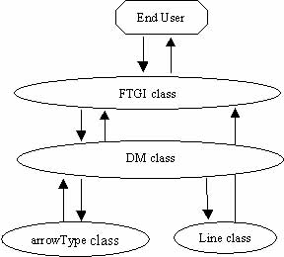
Another interesting example is the subgroup comprised of DM and arrowType objects. The DM class implements the DM object (see Figure 3.3-3). This class is used to coordinates display of the system’s reactions to the end user’s operations on the Drawing Menu. The menu of line choices appearing in the Drawing Menu is not implemented specifically for this project. Therefore, the FTGI class propagates the relationship labels to the DM class at “start-up”. After the labels are received they are used to create specific menu options through the arrowType class. Specifically the constructor of the arrowType class is invoked to instantiate menu selections with Arrow Types predefined by the relationship labels. These arrowType object instances are then inserted in the Arrow_Type_List. The Arrow_Type_List is an array in the DM class that contains all menu choices during application run time.
Figure 3.3-3 DM/arrowType Class Subgroup / End User Interaction
relationship
labels
buttons
Father –Son relationship

Father-Daughter relationship

Mother-Son relationship

Mother-Daughter relationship

Sister-Sister relationship

Brother-Brother relationship

Sister-Brother relationship
Husband-Wife relationships
boxes
In Figure 3.3-4 we can clearly see that the Drawing Menu is a collection of boxes, labels, and buttons. Each one of these components is an instance of a singular piece of code reused over and over again. When the end user selects one of the directed lines in order to create a relationship between two people, each instance of the arrow type button triggers a different type of relationship processing. This processing involves consistency checking which was described in detail in the previous section.
Figure 3.3-4 The Drawing Menu

And finally, another example of object oriented reuse is the MW class that represents a real-world message field. The MW class implements this object (see Figure 3.3-5). The
MW class
PDEF class
FTGI class
End User 2
End User 1
Figure 3.3-5 MW Class / End User Interaction
main functionality of this class is to take message input as a string and show it to the end user. This class is unique because both PDEF and FTGI classes use it. These are both observer object groups that have a Message Window provided as a part of the HMI. These Message Windows are used to make the end user aware of what happened inside the FTDB based on his/her action by displaying messages. These messages are received from either PDEF class or FTGI class and are propagated to the end user.

The types of messages that could be displayed are “OK” or “ERROR”. The “OK” message indicates the success of the operation triggered by the end user. On the other hand, an “ERROR” message indicates that something went wrong and that the specified update could not be committed. Table B-1 in Appendix B contains a complete list of messages displayed and their respective meanings.

4. Examples of FTDB System operations
This section presents several examples of the Family Tree Database (FTDB) system’s operations, as they are displayed to the end user via observers. The following examples present visual changes to the two HMIs triggered by internal changes of the states of the software objects.

4.1 PDEF HMI
Recall that People Data Entry Form (PDEF) is an observer group that represents a data entry form. This form is used to input people’s records into FTDB. Pressing the “Begin” button on the PDEF HMI starts the FTDB application. This action triggers extraction of records from the input file and their propagation to People List (PL) class. In the PL each incoming record is appended to the People_List linked list. These records are not checked for validity here because they were previously entered through the PDEF. Therefore, the data is assumed to be correct. As the data is read from the input file, we can see that information contained by each record is briefly displayed on the screen. Finally, when the last record is reached, its data stays on the screen (see Figure 4.1-1).
At this point the end user can update existing records, enter a new record, or use the Family Tree Graphical Interface (FTGI) HMI.
Figure 4.1-1 The last record from the input file

Recall that by nature of the observer design pattern the HMIs are independent from each other. Each interface can function alone, as well as jointly with the other interface. The PDEF interface has the following stand-alone functions. The end user can choose to update any field of an existing record except for the Social Security Number (SSN) field. Each field update is checked for data type correctness before its committed. For example, if the update is made to the Date of Birth (DOB) field, then new date is checked for compliance with the DOB-type format outlined in the Table 4.1-1. See Table B-2 in the Appendix B for the full list of fields and their data-type standards and type checking performed before incoming data is committed.

Table 4.1-1 DOB Standard
Standard appearance | Miscellaneous Definitions
mm/dd/yyyy | here “mm” is month, “dd” is a date, and “yyyy” is a year
mm/dd/yyyy | each m, y, and d is a digit
mm/dd/yyyy | 1<= mm <= 12
mm/dd/yyyy | 1<= dd <= 31 if mm = 1, 3, 5, 7, 8, 10, 12  1<= dd <= 30 if mm = 4, 6, 9, 11  1<= dd <= 28 if mm = 2 && yyyy != leap  1<= dd <= 29 if mm = 2 && yyyy == leap
mm/dd/yyyy | mm/dd/yyyy <= today

If the update is successful, the “OK RECORD UPDATE” message is displayed on the Message Window (MW). As shown in Figure 4.1-2.1, the DOB field was successfully updated from “01/13/1998” to “01/13/1999”. On the other hand, if one of the data-type constraints was violated, the observer object group is not allowed to change its state and an error message is displayed on the MW. In the case of the failed attempt to update the DOB, the “ERROR: FIELD (DOB)” message is generated on the MW. In Figure 4.1-2.2 an attempt to change the DOB to “13/13/1999” triggered an error message.

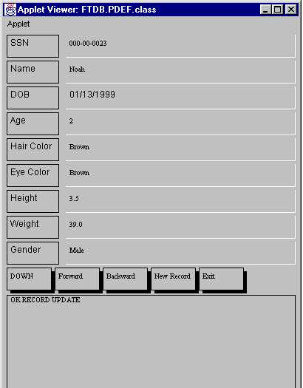
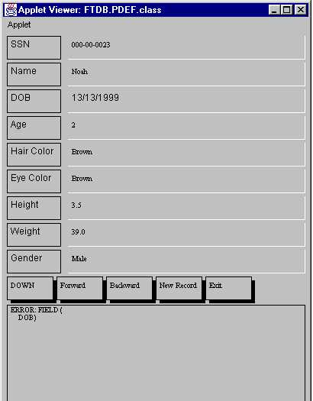
The end user can also choose to create a new record in the database. Pressing down the “New Record” button and entering data in all nine fields of the PDEF accomplishes this. The end user is expected to input information in succession from the SSN field down to the Gender field. The mouse is used to move from one text field to another. The “↵ Enter” key pressed at the end of the Gender field input triggers input data validation. If all the data is valid, then a new record is committed and the “OK NEW RECORD” message is displayed on the MW (see Figure 4.1-3.1). However, if errors are encountered, then the error is displayed and the record is not entered in the database. As we can see in the Figure 4.1-3.2, all nine fields violate imposed field-type constraints. Hence, the “ERROR: FIELD (SSN, Name, DOB, Age, Hair-Color, Eye-Color, Height, Weight, Gender)” message. The FTDB system also checks for duplicate records. For example, an attempt to create a record with the SSN of “000-00-0023” would produce an “ERROR: DUPLICATE RECORD” message. Duplicate records are also rejected.
Figure 4.1-2.2 Incorrect DOB field update
Figure 4.1-2.1 Correct DOB field update
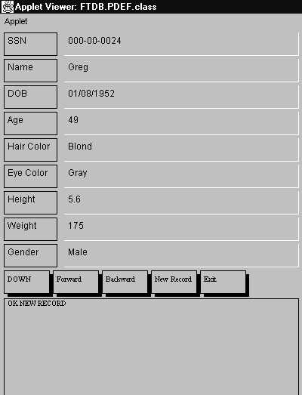
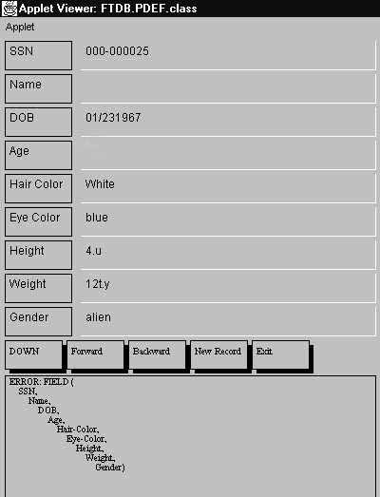
Figure 4.1-3.2 Error on the input
Figure 4.1-3.1 Valid new record

4.2 FTGI HMI
The FTGI HMI is also independent. Recall that the FTGI is an observer object group used to create relationships between existing instances of the Person object. However, it requires the database to be populated by person records in order to be operational. Recall that the end user must operate the mouse in order to use different features on this display. Every time a mouse click is made on the HMI, the underlying FTGI class queries the database for updates to the person records. If the name, age, or gender of a record has been changed via PDEF, then the FTGI displays the new information (see Figure 4.2-1). For example, if the name, age, and gender of the record “Mar” change from “Mar”, “54”, “Female” to “George”, “103”, and “Male”, the interface displays these changes to the end user (see Figures 4.2-2.1 and 4.2-2.2). There are several limitations outlined in Section 6 that restrict the extent of these updates. Also, if the database contains a new record, this fact is picked up during the next mouse click on the FTGI interface. The new record is displayed to the end user in the form of a new circle (in accordance with the rules of the observer pattern). For example, record “000-00-0024” for Greg was entered using PDEF after the initial set of circles was already displayed on the FTGI. The first mouse click made on the FTGI after the record was committed triggers an update of state of the FTGI observer. As a result, the new circle is displayed to the end user (see Figure 4.2-2.3).

The other feature of the FTGI interface is provided through the Drawing Menu (DM). Recall that the DM s a collection of bi-directional lines representing relationship types. The end user can click on one of the buttons on the DM in order to create a relationship between two people. For example, in order to create a Husband-Wife relationship between "Herman" and "Sara", the end user must select the "<--->" button representing the "Husband-Wife relationship" on the DM. As we can see in the Figure 4.2-3, the bi-directional line is replaced with the “DOWN” label, which indicates that the system is in the process of creating a new relationship of this type. Then the end user is expected to connect two circles (one male, one female) with the line representing such relationship. If one of the mouse clicks is not inside a circle, then the “ERROR: CONNECTIVITY” message is displayed on the MW and the attempt to create relationship should be repeated. If both mouse clicks are within existing circles, then the line is drawn and the relationship consistency checking mechanism contained by the subject object groups is invoked to check validity of the proposed relationship. If the relationship is valid, then “OK new Husband-Wife relationship” message is displayed on the MW and new relationship is committed and stored in the database. On the others hand, if proposed relationship violates one or more of the relationship constraints, appropriate error message is displayed on the MW and the proposed relationship is not allowed. For example, in the Figure 4.2-3, we can see the results of an attempt to create a Husband-Wife relationship between records “Jorn” and “Mar”. In this particular case the proposed relationship violated Husband-Wife relationship existence rules three and four (Not (Husband-Wife (P₁, P₃)) and Not (Husband-Wife (P₃, P₂)). Since “Jorn” is already married to “Annamarie” and “Mar” is married to “Mike”, the MW displays the following error message:

“ERROR:
Husband(Jorn)-Wife(Mar) RELATIONSHIP Not(Husband-Wife(Jorn,Annamarie))
Husband(Jorn)-Wife(Mar) RELATIONSHIP Not(Husband-Wife(Mike,Mar))”.
Here, the first part of each error corresponds to the proposed relationship and the second part is the relationship existence rule applied to the relationship integrity of which would be violated if the proposed relationship was committed.

After the end user is done creating particular relationship, he/she must enable the relationship-type button by clicking on it one more time. This is a shortcoming of the current implementation that is outlined in Section 6.
Mouse click
End User
PDSAM object group
New Info?
Yes(true) + New Info
No(false)
Display New Info
FTGI HMI

Figure 4.2-1 “Observer query the subject” observer pattern strategy

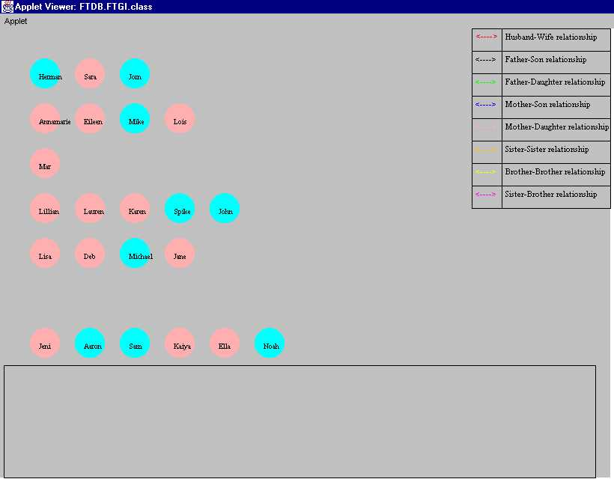

Figure 4.2-2.1 The initial set of person records

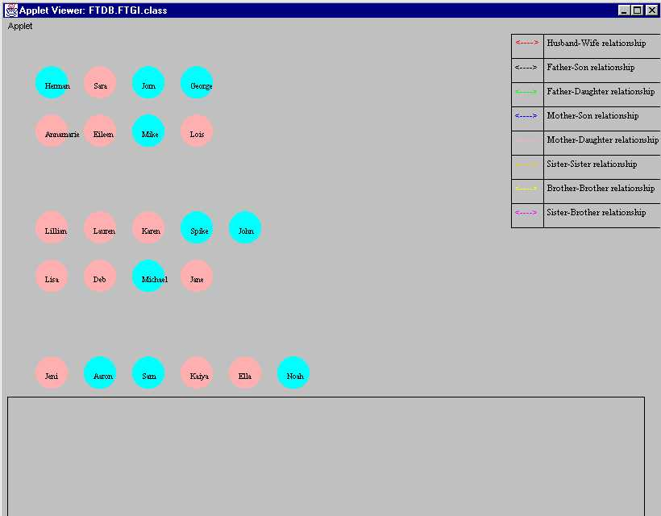

Figure 4.2-2.2 The update of record “Mar” to “George”

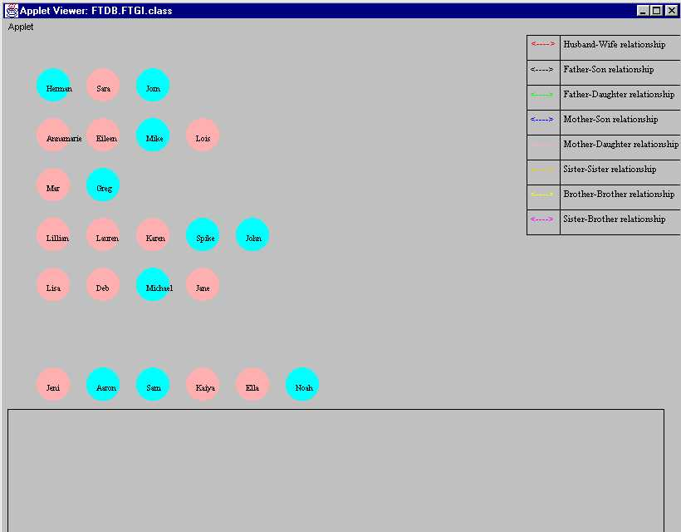

Figure 4.2-2.3 The new record – “Greg”

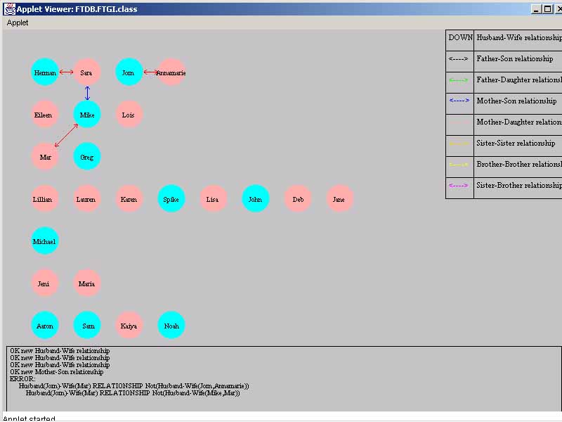
Figure 4.2-3 The results of unsuccessful attempt to create Husband(Jorn)-Wife(Mar) relationship

5. Summary
The main objective of this thesis was implementation of the observer design pattern (see Table 5-1).
Table 5- Thesis Objective vs. Achivement Summary Table
Thesis Objective | Achievement
Implement a concrete database system that illustrates the concept of the observer pattern | FTDB system is a concrete database system implemented using observer pattern technique called “observer query the subject” to maintain consistency constraints among a multitude of objects that comprise the database.
Investigate maintenance of consistency rules that are used for consistency checks during database transactions | Extensive testing has been conducted using a minimal set of programmable enforcement rules that define a subset of family relationships that could occur among family members. See [MT202] for test procedures and test results.

This objective was achieved by implementation of a concrete object oriented database system – the Family Tree Data Base (FTDB) system - using the concept of the observer pattern. The observer pattern technique called “observer query the subject” is used to maintain consistency constraints among a multitude of objects that comprise the database. Recall from previous sections of this thesis that the DBMS is comprised of two observer object groups and two subject object groups. The two observer groups serve as HMI’s. The two subject object groups serve as data storage and manipulation agents. Both observer groups of the schema are implemented independently from each other and can be removed from the system without any impact to the operations of the other object groups. The operations of the subject groups are associated more closely. There are small parts of the RDSAM that are dependent on the presence of people data that in the current implementation of the system can only be obtained through the PDSAM and the PDEF HMI. The ability to enter people data through the FTGI HMI is not part of this thesis. However, this capability is not difficult to implement and can be explored in the future efforts.

The observer design pattern is a perfect choice for the implementation of object-oriented databases. In this system we defined one-to-many relationships among objects. For example, when the FTGI object group is trying to change its state, it queries the RDSAM subject-object group with the request to “commit” the change. The RDSAM does an investigation and either notifies the HMI that the change can take place or that the change cannot be committed because it violates consistency constraints among existing objects of the database. If the change can take place, then all objects in the system are notified and the change takes place automatically. The HMI’s in the FTDB system are completely shielded from the data manipulation and do not have any knowledge of how many and which objects need to change their states to preserve consistency.

Recall that the FTDB system is implemented in JAVA. JAVA implementation allows the FTDB system great portability. This system was tested on the Windows 95, 98, 2000, and NT platforms. The system operated gracefully across all of these platforms. Also, as a totally object oriented language, JAVA was a great aid for the goal of creating an object-oriented database system. However, other features of JAVA proved to be difficult to deal with. The strings in JAVA are not equivalent to character arrays. This created an obstacle in the sense that external data had to be received in single character format and then converted to strings. By the same token outgoing data was converted from strings to single characters. Therefore, the system required additional parsing routines. This is the main reason for the introduction of a non-JAVA, commercially available interface to replace the PDEF HMI in the future (see Section 6.1). Another unanticipated discovery was the problem of selfish threads in the multi-applet environment. This issue surfaced early in implementation of the system and proved to be very difficult to overcome. In order to fix the problem a system-level method was modified to allow both HMI applets to coexist simultaneously.

As part of this thesis, we also researched maintenance of consistency rules that are used for consistency checks during database transactions. We implemented a minimal set of programmable enforcement rules that define a subset of family relationships that could occur among family members. These enforcement rules reside in both subject object groups. They are invoked when creation of a new object or update to an existing object is attempted. These rules are used to make sure that the change in state of the database does not violate any existing relationships before insertion/update transaction is committed. All relationship types are implemented as first-class citizens (concrete objects) of the RDSAM object group, thus integrating all classes into a unified global schema [KR95]. The system was designed with imbedded inheritance of family relationship existence rules. Namely, the more abstract relationship objects Relationship, Marriage, Sibling, and Ancestor have imbedded general relationship rules that are inherited by the concrete relationship object types. This implementation creates a solid base for automatic creation of existence rules. This effort is not part of this thesis and is further described in the Section 6.2.

6. Future Work
The implementation of the Family Tree Database (FTDB) system presented in this thesis is a solid example of realization of the observer design pattern thorough an object oriented database. However, this effort is just a beginning of research in the area of robust-object-oriented database design - design based on total synergy of all the objects involved in the database operations. In order to support this continuing effort, the system should become user-friendlier. Therefore, there are several improvements that should be made in the system. The first, is the replacement of the People Data Entry Form (PDEF) implemented in JAVA with a Commercial off the Shelf (COTS) product.

6.1 From JAVA based PDEF to COTS PDEF
The PDEF component of the FTDB was created as a support item of the FTDB system. It was designed in JAVA, just as the rest of the system, in order to illustrate the observer pattern in a homogeneous environment. However, it does not have to stay this way. Unfortunately, it proved to be "flaky" and would require a lot of extra work to make it compliant to commercially accepted design standards. Therefore, in order to make the HMI robust, we should replace it with a COTS product. One of the readily available COTS products that would do the job is Microsoft (MS) Access. This tool is accessible to everyone. It provides a simple development environment, that is easy to use in order to create a user friendly data entry form HMI or perhaps even a whole series of data entry forms and menus. In the Figure 6.1-1, we can see the PDEF implemented in MS Access.

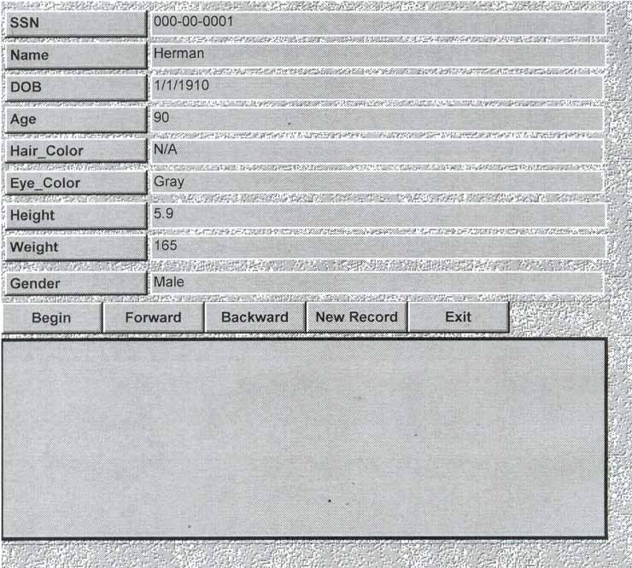
This form will serve as an interface only. All the data entered through this interface would be collected in a file and then sent over to the People Data Storage and Manipulation (PDSAM) class for processing. Recall that this is exactly how the system is working at present. However, in the new design the field-type consistency would be checked on the PDEF side. For example, MS Access can be programmed to accept valid date formats. This means that validity of Date of Birth (DOB) can be checked as the end user enters it. This will also allow a greater variety in date formats that could be employed. Furthermore, the PDSAM object group only has to check that the new record is not a duplicate and it does not violate imposed consistency constraints. After these checks the update is either committed or rejected. In either case a status message will be sent to the PDEF in order to be displayed to the end user in the Message Window (MW).
Figure 6.1-1 Person Data Entry Form

6.2 Automatic generation of existence rules and relationship types
Another area for future work is the Relationship Data Storage and Manipulation (RDSAM) object group. Namely, this object group should be rearranged to facilitate automatic generation of existence rules and relationship types. This would further generalize the implementation of this object group and provide a burning platform (baseline) for the automatic generation of existence rules.

6.2.1 Further Abstraction of the RDSAM Object Group
In order to abstract the implementation of the RDSAM object group further, we propose rearranging its internal positioning and interfaces, as in Figure 6.2.1-1, the RDSAM object now interfaces only with the Relationship object. Recall that before RDSAM object communicated with every <rel_name_list> object in the group. Therefore, the RDSAM object is no longer the main driver for relationship consistency checking. Instead it merely passes incoming relationship information to the Relationship object. The Relationship object then determines which general relationship group should receive the information in order to perform consistency checks. This is a better design because it reduces the number of interfaces and couplings among objects, but still exhibits modularity needed for different functionality.

Finally, each individual relationship group object is the controller for local inter-group coordination. Namely, the table containing existence rules for a particular relationship is passed up to the relationship group object. The relationship group object uses these rules as a roadmap for consistency checks.

The scheme outlined in this section is necessary for automatic generation of new rules. In the next subsection we are going to explore automatic generation of rules in more detail.

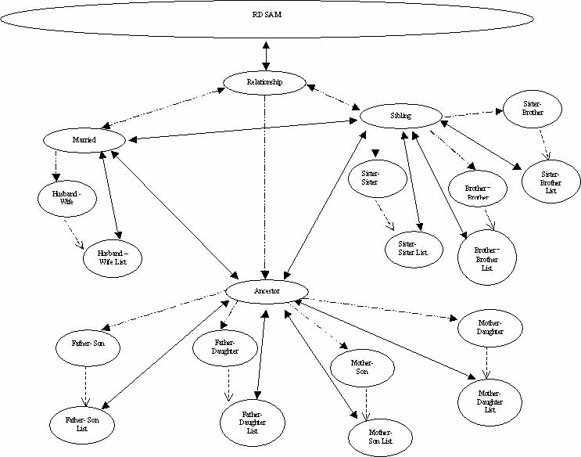
Figure 6.2.1-1 Restructured RDSAM Object Group

6.2.2 Automatic Generation of Relationship Types and Existence Rules
The main prerequisite for automatic generation of existence rules is automatic generation of new relationship groups and relationship types. In order to allow unclassified input into the relationship portion of the FTDB system, we should modify the Drawing Menu (DM) by allowing another menu choice. As we see in Figure 6.2.2-1, the DM is extended with the menu choice for a “New type relationship”. When the end user selects the button associated with this menu choice,
Sister-Brother relationships

New type relationship
X
X
P₁
P₂
Figure 6.2.1-1 Restructured RDSAM Object Group
he/she is expected to type in a name for proposed relationship and then create a directed line between two circles on the FTGI interface. After such connection is created, the database will follow the process outlined in Figure 6.2.2-2. First, the data associated with the proposed relationship will be propagated to RDSAM object and then to the Relationship object. At this point, the Relationship object through interaction with baselined (already existing) relationship group objects will make a determination regarding the proper disposition of the proposed relationship. If this
New relationship data
New relationship data
Valid new relationship/ new relationship type
New relationship data
Check for validity/ store
<rel_name_objects>
New relationship data
Generated/ violated
Baselined relationship group objects
New
Relationship group object
New relationship data
Check for validity/ create new relationship type object
Violate/ don’t violate integrity
DM object
MW object
Report action results
Create new menu choice on the DM
FTGI object
Valid new relationship/ new relationship type
Relationship object
RDSAM object
relationship is of a known type, then it will be checked for consistency using the processes outlined in subsection 3.2. If none of the existence rules are violated then the proposed relationship will be stored and the end user will be notified of success via the FTGI observer object group. On the other hand, if the relationship is of a new type, then this relationship object will spawn a new relationship group object. This new object will interact with already existing <rel_name_objects> in order to establish a proper relationship type for this new relationship. At this point we already know that the proposed relationship does not violate the integrity of the system because this relationship type does not exist in the system yet. Therefore, the purpose of this interaction is to conduct a pattern-matching exercise in order to establish the correct existence rules for the new relationship. For our example, let us assume that the two person objects from Figure 6.2.2-1 are involved in the relationships shown in the Figure 6.2.2-3.
Figure 6.2.2-2 Relationship validity checking/ relationship type creation process
X
P₁
P₆
P₂
P₄
P₅
P₃
Figure 6.2.2-3 The Relationship Map for (P₁, P₂)
In this case, the pattern-matching exercise will result in the existence rules of the Table 6.2.2-1.
Table 6.2.2-1 Half_Brother – Half_Sister Relationship Existence Rules
Rule # | Pattern Matching Result | Rule
1 | Male (P₁) | Male (X)
2 | Female (P₂) | Female (Y)
3 | Husband-Wife (P₁, P₆) | Not (Husband-Wife (X,Y)
4 | Father-Son (P₃,P₁) | --
5 | Father-Daughter (P₅,P₂) | --
6 | Mother-Son (P₄,P₁) | Mother-Son (Z,X)
7 | Mother-Daughter (P₄,P₂) | Mother-Daughter (Z,Y)

Then a new relationship type will be suggested and equivalent <rel_name_object> will be generated. Recall that all <rel_name_objects> contain “relationship existence rule” tables. Thus, data from the Table 6.2.2-1, which was compiled during New Relationship group object’s interaction with baselined <rel_name_objects>, will be included in the new object when it is created. Hence, this is the automatic generation of existence rules.

For the new relationship type of Half_Sister-Half_Brother, the current layout of the database will allow it as a valid relationship type. Therefore, an OK message will be propagated up to FTGI object. This object will notify the end user of this success by displaying the “OK new Half_Sister-Half_Brother relationship” on the MW and creating a new menu choice on the DM (see Figure 6.2.2-4).
Sister-Brother relationships

Half_Sister-Half_Brother relationship

New Type relationship
X
P₂
P₁
As we can see in the figure, the directed line between two circles has changed to match the one representing the Half_Sister-Half_Brother relationship. From this point forward, this is the definition of the Half_Sister-Half_Brother relationship. This definition cannot be changed on the next use of the application.
Figure 6.2.2-4 New DM Relationship Choice

This proposed implementation of the automatic rule generation raised some interesting discussions about whether the end user should be allowed to see the inferred constraints and participate in committing the new relationship by giving the final yes/no response to the FTDB's output. There are some pros and cons to this approach. The definite pro is that the user will get a relationship that he/she desires. On the other hand, this will somewhat violate the seamless principle of the observer design pattern by allowing the user to see internal data through an HMI. Furthermore, if we allow the end user to participate in generation of existence rules, we must assume that the user has enough knowledge to judge which rules should be attributed to the particular relationship that is being created.

6.3 Other Enhancements
This section lists other minor enhancements that should be carried out in conjunction with implementation of changes outlined in Sections 6.1 and 6.2. Table 6.3-1 contains description of the change, as well as the object groups and the classes in which the changes should be implemented.
Table 6.3-1 Other Enhancementns
Description of Change | Object Group | Class
Add drop-down menu allowing selection among multiple input files | PDEF | PDEF
Add multiple levels of access (i.e. Level 1 – “Create” and Level 2 – “Modify” | PDEF | PDEF
Make Hair_Color, Eye_Color, and Gender fields pull-down menus | PDEF | PDEF
Add a capability to set “alive/deceased” flag | PDEF & PDSAM | PDEF, PL, Person
Add code to simultaneously facilitate multiple family trees | PDSAM & RDSAM | PL, HWL, FSL, FDL, MSL, MDL, SSL BBL, SBL
Revamp FTGI HMI using commercial JAVA builder accessories | FTGI | FTGI, DM
Add support for “drag and drop” of the Family Tree elements on the FTGI HMI | FTGI | FTGI, CL, Circe, LL, Line
Add support for scaling of the Family Tree on the FTGI HMI | FTGI | FTGI
Support multiple views of the Family Tree (i.e. multiple layers) | FTGI | FTGI, CL, Circle, LL, Line
Output committed relationships information to test files on exit | RDSAM | RDSAM

Referenced and Applicable documents
This section lists literature cited in this thesis and consulted for this thesis.
[CH96] Gary Cornell, Cay S. Horstmann, “Core JAVA”, SUN Microsystems Inc.,
2550 Garcia Ave, Mountain View, CA 94043-1100, 1996
[CK99] Richard Clase, Danny Kopec, “How Should the Second Computer Science
Course (CS2) be Taught?", Panel presentation, Proceedings of the 4th Annual
CCSC NE Conference, Vol. 14, No. 4, 05/1999
[DF97] David Flanagan, “JAVA Examples is a Nutshell, A Tutorial Companion to
Java in a Nutshell", 1st edition, O’Reilly & Associates, Inc., 101 Morris St.,
Sebastopol, CA 95472, 1997
[DF99] David Flanagan, “JAVA in a Nutshell, A Desctop Quick Reference", 3rd
edition, O’Reilly & Associates, Inc., 101 Morris St., Sebastopol, CA 95472,
1999
[DK97] David M. Kronke, “Database Processing: Fundamentals, Design, and
Implementation”, 6th edition, Prentice Hall, Upper Saddle River, NJ 07458, 1997
[EN94] Ramez Elmasri, Shamkant B. Navathe, “Fundamentals of Database Systems",
2nd edition, College of Computing, GA Institute of Technology, 1994
[EN00] Ramez Elmasri, Shamkant B. Navathe, “Fundamentals of Database Systems",
3rd edition, Addison Wesley, 2000
[FW58] Funk and Wagnall, “Standard Reference Encyclopedia”, Standard Reference
Works Publishing Company, Inc., NY, New York, 1958
[GA96] Gary Aitken, “Moving from C++ to JAVA”, Dr. Dobb’s Journal, 1996
[GHJVB95] Erich Gamma, Richard Helm, Ralph Johnson, John Vlissides, Grady
Booch,“Design Patterns: Elements of Reusable Object-Oriented
Software”, Addison Wesley Professional Computing
[GM99] James Gosling, Henry McGilton, “The Java Language Environment: A White
Paper”, http://java.sun.com/docs/white/langenv/, 1996
[GR97] George Reese, “Database Programming with JDBC and JAVA”, O’Reilly &
Associates, Inc., 101 Morris Str., Sebastopol, CA 95472, 1997
[JK99] Jonathan Knudsen, “JAVA 2D Graphics", 1st edition, O’Reilly & Associates,
Inc.,101 Morris Str., Sebastopol, CA 95472, 1999
[JO98] Jayamani Odayappan, MS Thesis: "Semantic Framework for Architectural
Design Domain” , Department of Computer Science, URI, 1998
[KR94] Haruni A. Kuno and Elke A, Rundensteiner, “The MultiView OODB View
System: Design and Implementation”, Software Systems Research
Laboratory, University of Michigan, 1995
[LD97] Lisa Cingizer DiPippo, Computer Science 501, “JAVA Assignment: Mini-
Prolog Interpreter”, Department of Computer Science and Statistics, URI,
9 Greenhouse Rd., Suite 2, Kingston, RI 02881, 1997
[MD91] Michael Doherty, MS Thesis Proposal: "Semantic Relationships and
Database Object”, Department of Computer Science and Statistics, URI,
9 Greenhouse Rd., Suite 2, Kingston, RI 02881,1991
[MD92] Michael Doherty, MS Thesis: "Implementing Relationships in an Object-
Oriented Database”, Department of Computer Science and Statistics, URI,
9 Greenhouse Rd., Suite 2, Kingston, RI 02881,1992
[MM92] Martin E. Modell, “Data Analysis, Data Modeling, and Classification”,
McGraw-Hill, Inc., 1221 Avenue of the Americas, New York, NY 10020,
1992
[MT100] Mark J. Tseytlin, “Technical report: TR002-288", Department of Computer
Science and Statistics, URI, 9 Greenhouse Rd., Suite 2, Kingston, RI 02881,
March 2000
[MT200] Mark J. Tseytlin, “Technical Report: TR002-289”, Department of
Computer Science and Statistics, URI, 9 Greenhouse Rd., Suite 2, Kingston,
RI 02881, August 2000
[MT102] Mark J. Tseytlin, "Technical Report: TR002-290", Department of Computer
Science and Statistics, URI, 9 Greenhouse Rd., Suite 2, Kingston, RI 02881,
September 2002
[MT202] Mark J. Tseytlin, "Technical Report: TR002-291", Department of Computer
Science and Statistics, URI, 9 Greenhouse Rd., Suite 2, Kingston, RI 02881,
September 2002
[PM88] Joan Peckham, Maryanski, “Semantic Data Models”, ACM Computing
Surveys, Vol.20, No.3, September 1988
[PMD95] Joan Peckham, Bonnie MacKellar, Michael Doherty, “A Data Model for the
Extensible Support of Explicit Relationships in Design Databases”, VLDB
journal, Vol. 4, No. 2. April 1995, pg. 157-192
[PV96] Peter Van der Linden, “Just JAVA”, SUN Microsystems Inc., 2550 Garcia
Ave, Mountain View, CA 94043-1100, 1996
[WCS96] Larry Wall, Tom Christiansen & Randal L. Schwartz, "Programming Perl",
2nd Edition, O’Reilly & Associates, Inc., 101 Morris Str., Sebastopol, CA
95472, 1996

[WK95] Won Kim, “Modern Database Systems: The Object Model, Interoperability,
and Beyond”, ACM Press, New York, NY, 1995

Appendix-A Acronyms and Glossary
This section contains the table of acronyms and abbreviations used throughout this thesis and their respective definitions (see Table A-1). The acronyms are listed in alphabetical order for improved searchability. The definitions provided here are exact replicas of those provided on the first use of each acronym in the text of this thesis. Detailed descriptions of some specialized terms listed in this table can be found in the text of this document.

This section also contains a glossary of some specialized terms (see Table A-2) and a table containing specialized notation (see Table A-3) used in this thesis. All of these terms are first defined in the footnotes to this document.
Table A-1 List of Acronyms and Abbreviations
Acronym/ Abbreviations | Definition
BB | Brother-Brother
BBL | Brother-Brother List
DDL | Data Definition Language
DBMS | Database Management System
FD | Father-Daughter
FDL | Father-Daughter List
FS | Father-Son
FSL | Father-Son List
FTDB | Family Tree Database
FTGI | Family Tree Graphical Interface
HMI | Human-Machine Interface
HP | Hawlett-Packard laboratories
HW | Husband-Wife
HWL | Husband-Wife List
JVM | JAVA Virtual Machine
MD | Mother-Daughter
MDL | Mother-Daughter List
MS | Mother-Son
MSL | Mother-Son List
OAK | Object Application Kernel
OO | Object Oriented
OODM | Object-Oriented Data Model
PDEF | Person Data Entry Form
Acronym/ Abbreviations | Definition
PDSAM | People Data Storage and Manipulation
RDB | Relational Database
RDSAM | Relationship Data Storage and Manipulation
SB | Sister-Brother
SBL | Sister-Brother List
SS | Sister-Sister
SSL | Sister-Sister List
SORAC | Semantic Object Relationships And Constraints
TI | Texas Instruments
URI | University of Rhode Island
WWW | World Wide Web

Table A- 2 Glossary
Term | Definition
Active database system | A database system that monitors actions that may violate database constraints, and, when such actions occur, triggers an appropriate response in a timely manner.
Authorization | Identity based database access control
Concrete database system | A database system for a particular "real world" application
Inheritance | A characteristic of a system in which segments that are children obtain attributes (data) from their parent segment
JAVA Virtual Machine | JVM is the environment in which JAVA programs execute. JVM is a JAVA interpreter that uses the just-in-time (JIT) compilation principals, whereby JAVA byte codes are converted on-the-fly into native platform machine language .
Metadata | Information about the data such as class, attribute, and method definitions
Relationship | An association between two entities, objects, or rows of relations
Set-top-box | A TV-top digital signal decoder
Specialization | A technique used to extend the general definition of an object or class with a specialized definition of it.
Uses relationship | This is the most common relationship among cooperating objects. This relationship indicates that the behavior of one object depends on the behavior of another object. This relationship type is used to define dependencies of classes that cannot be effectively subclassed because they create foreign objects.
View | A virtual relation derived by a query on one or more stored relations and/or other views

Table A-3 Specialized Notation
Notation | Definition
 | Two-way communications between two object groups
 | Aggregation relation “has-part”
Notation | Definition
 | “Is-a” relation
 | One-way communication from one object group to an internal part of another object group
 | Two-way communications between internal parts of two object groups

Appendix-B Data Dictionary
This section contains detailed explanations for the data-messages used in this thesis (Table B-1). These document data flow generated by different components of the FTDB system. Also, in this section are the standards for PDEF inputs (Table B-2).

Table B- Message Definitions
Message | Definition
OK RECORD UPDATE | Successful update of an element of existing record
OK NEW RECORD | Successful generation of new record
ERROR: DUPLICATE RECORD | Unsuccessful attempt to insert a duplicate record
ERROR: FIELD (SSN) | Unsuccessful attempt to update SSN field of an existing record or data type error in the SSN field of a new record
ERROR: FIELD (SSN, Name, DOB, Age, Hair-Color, Eye-Color, Height, Weight, Gender) | Unsuccessful attempt to insert a new record where inputs for all the fields were incorrect
OK new Husband-Wife relationship | Successful creation of new Husband-Wife relationship
OK new Father-Son relationship | Successful creation of new Father-Son relationship
OK new Father-Daughter relationship | Successful creation of new Father-Daughter relationship
OK new Mother-Son relationship | Successful creation of new Mother-Son relationship
OK new Mother-Daughter relationship | Successful creation of new Mother-Daughter relationship
OK new Sister-Sister relationship | Successful creation of new Sister-Sister relationship
OK new Brother-Brother relationship | Successful creation of new Brother-Brother relationship
OK new Sister-Brother relationship | Successful creation of new Sister-Brother relationship
ERROR CONNECTIVITY | A mousse click that is not within any circle on the FTGI while one of the DM buttons is “DOWN”
ERROR: DUPLICATE Husband(P1)-Wife(P2) | Unsuccessful attempt to create duplicate Husband-Wife relationship
ERROR:  Male(P1)  Female(P2) | Unsuccessful attempt to create a relationship where the first person should be female a and the second person should be male
Message | Definition
ERROR:  Husband(P1)-Wife(P2) RELATIONSHIP Not(Husband-Wife(P1,P3))  Husband(P1)-Wife(P2) RELATIONSHIP Not(Husband-Wife(P4,P2)) | Unsuccessful attempt to create a Husband-Wife relationship between male and female that are married to other people
ERROR:  Husband(P1)-Wife(P2) RELATIONSHIP Not(Husband-Wife(P1,P3))  Sister(P2)-Brother(P1) RELATIONSHIP Not(Sister-Brother(P2,P1)) | Unsuccessful attempt to create a Husband-Wife relationship between male who is married to another female and his sister
ERROR:  Husband(P1)-Wife(P2) RELATIONSHIP Not(Husband-Wife(P1,P3))  Husband(P1)-Wife(P2) RELATIONSHIP Not(Husband-Wife(P4,P2))  Father(P1)-Daughter(P2) RELATIONSHIP Not(Father-Daughter(P1,P2)) | Unsuccessful attempt to create a Husband-Wife relationship between male and female that are married to other people and are also in the Father-Daughter relationship
ERROR:  Husband(P1)-Wife(P2) RELATIONSHIP Not(Husband-Wife(P1,P3))  Mother(P2)-Son(P1) RELATIONSHIP Not(Mother-Son(P2,P1)) | Unsuccessful attempt to create a Husband-Wife relationship between male who is married to another female and his mother
ERROR:  Male(P1)  Male(P2)  Age(P1)- Age(P2)>= 15 | Unsuccessful attempt to create a Father-Son relationship between two females where perspective son is less than 15 younger then perspective father
ERROR:  Age(P1)- Age(P2)>= 15  Brother(P1)-Brother(P2) RELATIONSHIP Not(Brother-Brother(P1,P2)) | Unsuccessful attempt to create a Father-Son relationship between two brothers whose age difference is less than 15 years
ERROR:  Male(P1)  Female(P2)  Age(P1)- Age(P2)>= 15 | Unsuccessful attempt to create a Father-Daughter relationship between female and male whose age difference is less than 15 years
ERROR:  Age(P1)- Age(P2)>= 15  Father(P1)-Daughter(P2) RELATIONSHIP Not(Husband-Wife(P1,P2)) | Unsuccessful attempt to create a Father-Daughter relationship between husband and wife whose age difference is less than 15 years
ERROR:  Age(P1)- Age(P2)>= 15  Sister(P1)-Brother(P2) RELATIONSHIP Not(Sister-Brother(P1,P2)) | Unsuccessful attempt to create a Mother-Son relationship between siblings whose age difference is less then 15 years
ERROR:  Female(P1)  Male(P2)  Age(P1)- Age(P2)>= 15 | Unsuccessful attempt to create a Mother-Son relationship between male and female whose age difference is less than 15 years
ERROR:  Age(P1)- Age(P2)>= 15  Husband(P2)-Wife(P1) RELATIONSHIP Not(Husband-Wife(P2,P1)) | Unsuccessful attempt to create a Mother-Son relationship between married people whose age difference is less than 15 year
ERROR:  Age(P1)- Age(P2)>= 15  Sister(P1)-Brother(P2) RELATIONSHIP Not(Sister-Brother(P1,P2))” | Unsuccessful attempt to create a Mother-Son relationship between siblings whose age difference is less then 15 years
ERROR:  Female(P1)  Female(P2)  Age(P1)- Age(P2)>= 15” | Unsuccessful attempt to create a Mother-Daughter relationship between two males whose age difference is less than 15 years
Message | Definition
ERROR:  Age(P1)- Age(P2)>= 15  Sister(P1)-Sister(P2) RELATIONSHIP Not(Sister-Sister(P1,P2)) | Unsuccessful attempt to create a Mother-Daughter relationship between two sisters whose age difference is less then 15 years
ERROR:  Female(P1)  Female(P2) | Unsuccessful attempt to create a relationship between two females when two male records are supplied
ERROR:  Mother(P1)-Daughter(P2) RELATIONSHIP Not(Mother-Daughter(P1,P2)) | Unsuccessful attempt to create a Sister-Sister relationship between a mother and a daughter
ERROR:  Male(P1)  Male(P2) | Unsuccessful attempt to create a relationship between two people where both people should be men, but two female records are supplied
ERROR:  Father(P1)-Son(P2) RELATIONSHIP Not(Father-Son(P1,P2)) | Unsuccessful attempt to create Brother-Brother relationship between a father and a son
ERROR:  Female(P1)  Male(P2) | Unsuccessful attempt to create a relationship where the first person should be female a and the second person should be male, but a male and a female records were supplied
ERROR:  Husband(P2)-Wife(P1) RELATIONSHIP Not(Husband-Wife(P2,P1)) | Unsuccessful attempt to create a Sister-Brother relationship between two married people
ERROR:  Mother(P1)-Son(P2) RELATIONSHIP Not(Mother-Son(P1,P2)) | Unsuccessful attempt to create a Sister-Brother relationship between a mother and a son
ERROR:  Father(P2)-Daughter(P1) RELATIONSHIP Not(Father-Daughter(P2,P1)) | Unsuccessful attempt to create a Sister-Brother relationship between a father and a daughter

Table B- 2 Input types and their standards
Input Type | Standard appearance | Miscellaneous Definitions
date | mm/dd/yy | here “mm” is month, “dd” is a date, and “yy” is a year
date | mm/dd/yy | each m, y, and d is a digit
date | mm/dd/yy | 1<= mm <= 12
date | mm/dd/yy | 1<= dd <= 31 if mm = 1, 3, 5, 7, 8, 10, 12  1<= dd <= 30 if mm = 4, 6, 9, 11  1<= dd <= 28 if mm = 2 && yy != leap  1<= dd <= 29 if mm = 2 && yy == leap
date | mm/dd/yy | mm/dd/yy <= today
double | n.n or n. | number with fractional part that could be blank (JAVA adds a 0)
SSN | nnn-nn-nnn | here each “n” is a digit
int | n | number without fractional part
Gender | Male or Female

Appendix-C Relationship Existence Rules
This section contains existence rules for all relationship types defined in the FTDB System (Table C-1). The rules are ordered by relationships. The right column in the table below indicates which class is invoked to check validity of each rule.
Table C-1 Relationship Existence Rules
Relationship Name | Rule # | Rule | Consistency Checked by class
Husband-Wife | 1 | Male (P₁) | PL class
Husband-Wife | 2 | Female (P₂) | PL class
Husband-Wife | 3 | Not (Husband-Wife (P₁, P₃)) | HW class
Husband-Wife | 4 | Not (Husband-Wife (P₃, P₂)) | HW class
Husband-Wife | 5 | Not (Sister-Brother (P₂, P₁)) | SB class
Husband-Wife | 6 | Not (Father-Daughter (P₁, P₂)) | FD class
Husband-Wife | 7 | Not (Mother-Son (P₂, P₁)) | MS class
Father-Son | 1 | Male (P₁) | PL class
Father-Son | 2 | Male (P₂) | PL class
Father-Son | 3 | Age (P₁) – Age (P₂) ≥ 15 | RDSAM class
Father-Son | 4 | Not (Brother-Brother (P₁, P₂)) | BB class
Father-Daughter | 1 | Male (P₁) | PL class
Father-Daughter | 2 | Female (P₂) | PL class
Father-Daughter | 3 | Age (P₁) – Age (P₂) ≥ 15 | RDSAM class
Father-Daughter | 4 | Not (Husband-Wife (P₁, P₂)) | HW class
Father-Daughter | 5 | Not (Sister-Brother (P₂, P₁)) | SB class
Mother-Son | 1 | Male (P₂) | PL class
Mother-Son | 2 | Female (P₁) | PL class
Mother-Son | 3 | Age (P₁) – Age (P₂) ≥ 15 | RDSAM class
Mother-Son | 4 | Not (Husband-Wife (P₂, P₁)) | HW class
Mother-Son | 5 | Not (Sister-Brother (P₁,P₂)) | SB class
Mother-Daughter | 1 | Female (P₁) | PL class
Mother-Daughter | 2 | Female (P₂) | PL class
Mother-Daughter | 3 | Age (P₁) – Age (P₂) ≥ 15 | RDSAM class
Mother-Daughter | 4 | Not (Sister-Sister (P₁, P₂)) | SS class
Sister-Sister | 1 | Female (P₁) | PL class
Sister-Sister | 2 | Female (P₂) | PL class
Sister-Sister | 3 | Not (Mother-Daughter (P₁, P₂)) | MD class
Sister-Sister | 4 | Not (Mother-Daughter (P₂, P₁)) | MD class
Brother-Brother | 1 | Male (P₁) | PL class
Brother-Brother | 2 | Male (P₂) | PL class
Brother-Brother | 3 | Not (Father-Son (P₁, P₂)) | FS class
Brother-Brother | 4 | Not (Father-Son (P₂, P₁)) | FS class
Sister-Brother | 1 | Female (P₁) | PL class
Sister-Brother | 2 | Male (P₂) | PL class
Sister-Brother | 3 | Not (Husband-Wife (P₂, P₁)) | HW class
Sister-Brother | 4 | Not (Mother-Son (P₁, P₂)) | MS class
Sister-Brother | 5 | Not (Father-Daughter (P₂, P₁)) | FD class

Appendix-D FTDB System Code
This section contains the listing of all the classes used in implementation of the Family Tree Database (FTDB) System (Table D-1). These classes are arranged in alphabetical order. The right column provides a short description of the purpose of each class. See [MT200] for detailed English-like descriptions of all classes.

There are forty JAVA and one HTML modules that implements the FTDB. See [MT102] for code that implements these modules.
Table D- 1 Classes implementing FTDB System
Object Name | Class Name | Class Description
Ancestor | Ancestor | This class implements an abstract representation of a real-world Ancestor object
arrowType | arrowType | This class implements an instance of a double-sided arrow
Brother-Brother Relationship | BB | This class implements a concrete object representing a real-world Brother-Brother Relationship
Brother-Brother Linked List | BBL | This class implements a linked list of Brother-Brother Relationship objects and linked list operations associated with it (including consistence checking)
button | button | This class implements an instance of a real world button for the PDEF interface
Circle | Circle | This class implements an instance of a real world circle for FTGI interface
Circle Linked List | CL | This class implements a linked list of Circle objects and linked list operations associated with it
Drawing Menu | DM | This class implements the Drawing Menu object for the FTGI interface and all its associated operations
Eye Color | eyeColor | This class implements a concrete instance of a real-world Eye Color object
Father-Daughter Relationship | FD | This class implements a concrete object representing a real-world Father-Daughter Relationship
Father-Daughter Linked List | FDL | This class implements a linked list of Father-Daughter Relationship objects and linked list operations associated with it (including consistence checking)
field | field | This class implements an instance of a data entry form text field (including the label) for the PDEF interface
Father-Son Relationship | FS | This class implements a concrete object representing a real-world Father-Son Relationship
Father-Son Linked List | FSL | This class implements a linked list of Father-Son Relationship objects and linked list operations associated with it (including consistence checking)
Object Name | Class Name | Class Description
Family Tree Graphical Interface | FTGI | This class implements the FTGI HMI including all of its operations
Gender | Gender | This class implements a concrete instance of a human gender
Hair Color | hairColor | This class implements a concrete instance of a real-world Hair Color object
Husband-Wife Relationship | HW | This class implements a concrete object representing a real-world Husband-Wife Relationship
Husband-Wife Linked List | HWL | This class implements a linked list of Husband-Wife Relationship objects and linked list operations associated with it (including consistence checking)
Line | Line | This class implements a concrete instance of a real-world line object used on the FTGI HMI
Line Linked List | LL | This class implements a linked list of Line objects and linked list operations associated with it
Married | Married | This class implements an abstract representation of a real-world Married Relationship object
Mother-Daughter Relationship | MD | This class implements a concrete object representing a real-world Mother-Daughter Relationship
Mother-Daughter Linked List | MDL | This class implements a linked list of Mother-Daughter Relationship objects and linked list operations associated with it (including consistence checking)
Mother-Son Relationship | MS | This class implements a concrete object representing a real-world Mother-Son Relationship
Mother-Son Linked List | MSL | This class implements a linked list of Mother-Son Relationship objects and linked list operations associated with it (including consistence checking)
Message Window | MW | This class implements an instance of a message window displaying all messages from the FTDB system to the end user
myUtilities | myUtilities | This class is used to provide type-checking utilities for non-standard data types (i.e. SSN, DOB, and Gender)
Person Data Entry Form | PDEF | This class implements the main object of the PDEF observer HMI and all of its associated functions
People Data Storage and Manipulation | PDSAM | This class implements the main object of the PDSAM subject object group and all of its associated functions (i.e. people record storage and manipulation)
Person | Person | This class implements an instance of a real-world Person object
People Linked List | PL | This class implements a linked list of People objects and linked list operations associated with it
Relationship Data Storage and Manipulation | RDSAM | This class implements the main object of the RDSAM subject object group and all of its associated functions (i.e. relationship date storage and manipulation)
Relationship | Relationship | This class implements an abstract representation of a real-world Relationship object
Sister-Brother Relationship | SB | This class implements a concrete object representing a real-world Sister-Brother Relationship
Sister-Brother Linked List | SBL | This class implements a linked list of Sister-Brother Relationship objects and linked list operations associated with it (including consistence checking)
Sibling | Sibling | This class implements an abstract representation of a real-world Sibling Relationship object
Sister-Sister Relationship | SS | This class implements a concrete object representing a real-world Sister-Sister Relationship
Object Name | Class Name | Class Description
Sister-Sister Linked List | SSL | This class implements a linked list of Sister-Sister Relationship objects and linked list operations associated with it (including consistence checking)
universalColor | universalColor | This class implements an abstract representation of a real-world Color object

Bibliography
Anonymous, “Compilation of Object-Oriented Languages”
Gary Aitken, “Moving from C++ to JAVA”
Lisa Cingizer DiPippo, Computer Science 501, “JAVA Assignment: Mini-Prolog
Interpreter”
Richard Clase, Danny Kopec, “How Should the Second Computer Science Course
(CS2) be Taught?"
Gary Cornell, Cay S. Horstmann, “Core JAVA”
Michael Doherty, MS Thesis Proposal: "Semantic Relationships and Database
Object”
Michael Doherty, MS Thesis: "Implementing Relationships in an Object-Oriented
Database”
Ramez Elmasri, Shamkant B. Navathe, “Fundamentals of Database Systems", 2nd
edition
Ramez Elmasri, Shamkant B. Navathe, “Fundamentals of Database Systems", 3rd
Edition
Erich Gamma, Richard Helm, Ralph Johnson, John Vlissides, Grady Booch, “Design
Patterns: Elements of Reusable Object-Oriented Software"
GemStone Systems, "GemStone FacetsTM: Real Time, Real Money", Technical
Overview, http://www.gemstone.com/products/Facets_Whitepaper.pdf, 11/14/2002
James Gosling, Henry McGilton, “The Java Language Environment: A White Paper”,
http://java.sun.com/docs/white/langenv/, 06/06/2002
David Flanagan, “JAVA Examples is a Nutshell, A Tutorial Companion to Java in a
Nutshell", 1st edition”
David Flanagan, “JAVA in a Nutshell, A Desctop Quick Reference", 3rd edition
Funk and Wagnall, “Standard Reference Encyclopedia”
Won Kim, “Modern Database Systems: The Object Model, Interoperability, and
Beyond"
Jonathan Knudsen, “JAVA 2D Graphics", 1st edition
David M. Kronke, “Database Processing: Fundamentals, Design, and
Implementation", 6th edition
Haruni A. Kuno and Elke A, Rundensteiner, “The MultiView OODB View System:
Design and Implementation”
Martin E. Modell, “Data Analysis, Data Modeling, and Classification”
Jayamani Odayappan, MS Thesis: "Semantic Framework for Architectural Design
Domain”
Joan Peckham, Maryanski, “Semantic Data Models”
Joan Peckham, Bonnie MacKellar, Michael Doherty, “A Data Model for the
Extensible Support of Explicit Relationships in Design Databases”
George Reese, “Database Programming with JDBC and JAVA”
Mark J. Tseytlin, “TR002-288: The Observer Design Pattern and the Maintenance of
Consistency Constraints in an Object-Oriented Database, Proposal for MSCS Thesis"
Mark J. Tseytlin, “TR002-289: The Observer Design Pattern and the Maintenance of
Consistency Constraints in an Object-Oriented Database, Project Specification",
Rev E
Mark J. Tseytlin, "TR002-290: The Observer Design Pattern and the Maintenance of
Consistency Constraints in an Object-Oriented Database, FTDB System Code", Rev -
Mark J. Tseytlin, "TR002-291: The Observer Design Pattern and the Maintenance of
Consistency Constraints in an Object-Oriented Database, FTDB System Test
Procedures and Test Results", Rev -
Peter Van der Linden, “Just JAVA"
Larry Wall, Tom Christiansen & Randal L. Schwartz, "Programming Perl"
Kevin Wilkinson, Peter Lyngbaek, Waqar Hasan, "The Iris Architecture and
Implementation", http://www.hpl.hp.com/techreports/90/HPL-90-108.pdf, 11/14/2002

Concrete database system is a database system for a particular "real world" application.
Inheritance is a characteristic of a system in which segments that are children obtain attributes (data) from their parent segment.
A relationship is an association between two entities, objects, or rows of relations.
An active database system is a database system that monitors actions that may violate database constraints, and, when such actions occur, triggers an appropriate response in a timely manner.
Specialization is a technique used to extend the general definition of an object or class with a specialized definition of it.
Metadata is information about the data such as class, attribute, and method definitions.
A view is a virtual relation derived by a query on one or more stored relations and/or other views.
Authorization is identity based database access control.
A set-top-box is a TV-top digital signal decoder.
JVM - the environment in which JAVA programs execute. JVM is a JAVA interpreter that uses the just-in-time (JIT) compilation principals, whereby JAVA byte codes are converted on-the-fly into native platform machine language .
This information can also be found in Appendix A (Table A-3).
Uses relationship - a most common relationship among cooperating objects. This relationship indicates that the behavior of one object depends on the behavior of another object. This relationship type is used to define dependencies of classes that cannot be effectively subclassed because they create foreign objects [WCS96].
This information can also be found in Appendix A (Table A-3).
The meanings of different types of arrows can be found in Appendix A (Table A-3).
The meanings of different types of arrows can be found in Appendix A (Table A-3).
The meanings of different types of arrows can be found in Appendix A (Table A-3).
The meanings of different types of arrows can be found in Appendix A (Table A-3).

