Travel Time Prediction in Rhode Island

Introduction:

A travel-time prediction system is a an automated system for predicting and displaying travel time for motorists on a regular free flow stretch of roadway or though work zones on a real time basis. The general protocol for a prediction system collects the data from the sensor’s on the highway, processes the data in an onsite personal computer, computes the travel time between different point locations on the freeway and displays the information on changeable message signs (CMS). Using such a system, traffic engineers are able to portray the traffic conditions ahead of time for the travelers. This allows the motorists to make decisions about staying on the freeway or taking an alternate route.

Many research efforts emphasize the significance of traffic information and the potential effect of advance traveler information systems (ATIS) on route choice. For instance travelers are classified as so-called captives and non-captives. For captives i.e. the drivers with no feasible alternate routes, traffic information reduces the uncertainty regarding future traffic conditions. This assists the drivers to anticipate queues downstream and possibly increases the driving comfort while reducing driving stress. These factors influence the drivers’ behaviors and these behaviors can hence be controlled to some extent. Secondly for the non-captives, it not only reduces uncertainity but also keeps multiple choices open. Overall this will have a positive effect on the experienced traffic conditions and lead to more efficient use of the available roadway network.

Lack of real-time travel-time or delay information in freeway construction work zones is one of the main causes for motorist frustration today. The need for better information for drivers in work zones is reinforced by the fact that “each year upwards of 1,000 fatalities occur in work zones alone. In 1999 alone, there were 868 work zone accident fatalities. In addition there are many more injuries. Factors contributing to these accidents include exceeding safe speed limits and lack of proper notice of the expected delays prior to the work zones. Hence the key advantage of the travel time prediction system would be to provide the motorists with travel time information in advance of the work zone on a real time basis thereby reducing the congestion and frustration of the travelers.

In our previous projects, we designed a software architecture for integrating the various types of real-time and archived data that are needed to support Intelligent Transportation Systems (ITS). In the second year, we developed a design and software prototype that is capable of displaying real-time highway traffic conditions similar to that which is displayed in Seattle at http://www.wsdot.wa.gov/PugetSoundTraffic/. In the third year we developed a design and prototype software to integrate the previous traffic conditions interface and data to permit users to ask questions about planned and unplanned anomalies. This included a web based interface for transportation professionals to enter and maintain information about planned anomalies, and for agencies and companies outside RIDOT to gain permission for road closures and alterations in a paper-free but secure web-based environment. Also included was a means for safety officials to enter real-time information about accidents and other weather or traffic related incidents. All of this information was fused into an algorithm (step-by-step procedure) for detecting and reporting anomalies, traffic conditions, and planned incidents through a GIS based interface. This required the integration of GIS, database and web-based technologies. Below we report on the next step of our investigations into ITS technologies for RI with a focus upon the gathering and reporting of travel times on freeways in the state.

Requirements for travel time prediction:

Traffic information often consists of indirect information, that is, information that has to be interpreted by the traveler before being useful. How ever indirect information is not always optimal. For instance a traffic jam of 2 km caused by a truck blocking two lanes, could result in a much higher travel times than a regular traffic jam of 4 km on a well known bottleneck. However, even under seemingly comparable traffic circumstances different travel times can be experienced due to different traffic conditions, seasonal effects, and weather conditions. To fully utilize the potential real- time traffic information, a system should be developed that is capable of producing accurate and reliable estimates and predictions of the travel times under all possible traffic conditions and circumstances. This robustness in the prediction system can be achieved by efficient combination of different data sources ranging from inductive loop data, floating car data, weather forecasts, GPS data etc.

Possible sources of data:

Both real-time and historic data from different sources are needed to design an accurate traffic prediction system. Among these sources are,

- Data from inductive loops (speed, flowrates, occupancy)
- Data from traffic control and ramp metering systems (phases, green times, speed, occupancy, presence).
- Data from automatic vehicle identification (AVI) or video detection systems (speed, travel times)
- Data from probe vehicles, instrumented vehicles driving in the traffic flow that send position at regular time intervals to a monitoring system (travel times, routes)
- Historical and forecast weather data
- Temporal information (season, day of week, hour of day, special occasions)
- Infrastructure related information such as planned road works and lane closures and ramp closures.
- Data from incident detection systems (lane closures, severity, expected duration)
- Anecdotal data.

Literature Review:

Basic Definitions relating Travel Time:

Individual Travel Time: Individual Travel Time is defined as the time required for a vehicle to traverse a particular route R from X_{o} to X_{n} starting at time T_{o}.

Aggregated Travel Time: One way of aggregating individual travel times is averaging the individual travel times over the total number of vehicles traversing Route R during a particular time period.

Basic Difference between Travel time estimation and Travel time Prediction:

Travel time estimation is basically calculating or approximating travel times after the trips have been completed. Estimates of past and prevailing travel times give insight into the actual and past conditions on the road network. Different techniques have been developed to estimate travel times on the bases of time-averaged speeds and traffic volumes.

Travel time prediction is basically calculating or approximating of travel times before the trips are made. Travel time prediction requires fundamental knowledge of the models that are capable of learning and simulating these processes.

Fuzzy-Neural Network traffic prediction framework with wavelet decomposition[1]:
Significant research is being done to predict travel-time using data received from various sources. All the approaches used for traffic prediction are dictated by the fact that traffic conditions are time dependent and often follow fairly well defined patterns. Various approaches to travel-time and traffic prediction involve wavelet transforms, neural networks and fuzzy logic. In this approach emphasis is given to wavelet de-noising methods. The model developed in this paper is based on predicting the traffic speed based on historic travel speed profile along a link. The data used in the research was collected from Houston and was used to generate a speed profile for a particular day. This paper identified the peak hour as 6 am to 9:30 am. The basic pattern in the historical data was recognized and future prediction was applied. Wavelet transform is a tool, which has the ability to analyze non-stationary signal to obtain their trends and discover the traffic trends. The unexpected information in the traffic patterns is treated as noise. The noises are then filtered using the wavelet transform. In this, a deterministic strong part is obtained by setting to zero all the wavelet coefficients less than a certain threshold level. Inverse wavelet transform is used to calculate the corresponding time series. Similarly the weak part was obtained by setting to zero all wavelet coefficients greater than the threshold level. The inverse wavelet transform is also used here to calculate the corresponding time series. A new wavelet spectrum was calculated for each partial time series. Significant features were extracted by comparing the time series during the influenced time period and its standard pattern. A neuro-fuzzy network is used to identify the influence of special factors to the specific pattern.

A simple and effective method for predicting travel times on freeways [4]:
The methodology used in this paper explains about prediction of travel time on a given stretch of freeway when departure is at a given time in future. The groundwork in this approach is done on the basis of current traffic situation in combination with historical data. Prediction is done on the basis of current travel time information. The current travel time status was estimated from the single loop detectors or double loop detectors, video data, probe vehicles. Data was recorded as flow and occupancy from 116 loop detectors along 48 miles of I-10 East in Los Angeles. Measurements were done at 5 min aggregation at times ranging from 5 am to 9 pm for 34 weekdays. The flow and occupancy data were converted to velocity using a g factor.
Velocity = g * flow/occupancy
According to Jia et al [10], if the occupancy data is below a certain threshold say 10 percent, then it is assumed that the freeway is in a state of free flow with nominal speeds of 60 mph. Hence the g factor is determined keeping the velocity fixed. Similarly when it exceeds the threshold, g factor is kept fixed to the past value by varying the velocity thereby determining the velocity changes.

The empirical fact in this prediction methodology was based on the linear relationship between the future travel time and the current status travel time. The slope and intercept of this relationship is observed for various times of day. A matrix V with entries V (d,l,t) (d∈D; l∈L; t∈T) denoting the velocity that was measured on day d at loop l at time t. From V travel times were computed TTd (a; b; t), for all d ∈ D, a; b∈ L and t ∈ T. This approximates the time it took to travel from loop a to loop b starting at time t on day d. A proxy for these travel times was computed which is defined by

T_ d (a, b, t) =

Where di denotes the distance from loop i to loop (i+1). T_d is the current status of travel- time. It is the travel time that would have resulted from departure from loop a at time t on day d when no significant changes in traffic occurred until loop b was reached. It is important to notice that the computation of T_ d (a, b, t) only requires information available at time t, whereas computation of TTd (a, b, t) requires information of later times. The main useful result of this paper for us is the discovery of the empirical fact that there exists a linear relationships between T_d (t) and TT (t+ ∂) for all t and ∂. This empirical finding has held up in all of numerous freeway segments in California that were examined.

The proposed model was of the type,

TT (t +∂ ) = α(t,∂ )T_d (t) +β (t,∂ ) + ε

where ε is a zero mean random variable modeling random fluctuations and measurement errors. Note that the parameters α and β are allowed to vary with t and the future travel time is a linear combination of historical mean and the current status travel time.

Robust and adaptive travel time prediction with Neural Networks [2]:
Artificial neural networks are a class of mathematical models, capable of approximating any non-linear mapping to an arbitrary accuracy. This universal approximation theorem does not reveal however, the many practical difficulties in designing and training ANN’s. With out some basic insight of mathematics of non linear mapping in spaces of high dimensionality and awareness of some well known pitfalls such as getting trapped in the local minima, over fitting and under fitting, ANN approach is not likely to be successful.

The goal of neural network training is not to learn a representation of training data itself, but to build a statistical model of the process generating the data. ANN’s are typically used for complex non-linear function approximation and pattern recognition. Examples are credit card fraud detection, sales prediction, medical diagnosing, character recognition and weather forecasting.

A System for displaying travel time on changeable message signs [5]:
This paper presents an implementation of real time travel time prediction on changeable message sign (CMS) and its potential benefits. Loop Detector measurements are used to display travel time estimates on CMS’s and effectively deliver traveler information to drivers. An algorithm that operates on real time data and produces predictions every five minutes is discussed as follows (An algorithm is a sequence of steps, programmable by a computer or other computational or control device, that provides a solution to a problem or a specified set of problems.)
Travel time predictions are computed using linear regression. A route is divided into n segments of length l_{i}, i = 1, 2, . . . n, where the segment boundaries are located at the midpoints between adjacent detection detectors. For a given time t, instantaneous travel time is defined as
Where is the speed measured by the ith detector at t. T* represents the current state of the route, it is a predictor of the actual travel time T (t) in the linear model:
Here t is the intended departure time, s is the time of most recent data, and ε(t, s) is noise. The coefficients α and β are functions of t and s. They are estimated from historical data and stored in the database. X(t) is the predictor of travel time for the current state of traffic. The travel time prediction at current time t is found using the estimates of α and β:

The complete system includes the travel time predictor and a program at the Traffic Management Center, which reads the predictions and displays them onto the designated signs. Using real time information often enables the driver to select the quickest route and avoid congestion.
Loop data based travel time estimates are compared with probe vehicle measurements. There is good agreement between the two when the data quality is good. Although more probe measurements will be performed to verify that the data quality is good enough for deployment. The RMS error was estimated as about 14%.

Limitations for the above travel time estimations to be accurate are
- The detector data must be valid and detector spacing must be small enough to capture the true speed profile of the vehicles.
- Since detectors often fail, producing bad data or no data at all, one must verify travel times based on loop data against those directly measured with probe vehicles.
- In many cases, a large number of samples are missing from the data, which results in large errors

Accurate estimation of travel times from single-loop detectors [6]:
This paper presents a method to obtain accurate estimates of travel times by using the high-resolution flow and occupancy data directly from the single-loop detector data without heavy reliance on the speed calculations.
This method assumes that during a given interval of time the travel times may be regarded as draws from the same probability distribution, it then estimates that distribution, and in particular its mode from the cumulative upstream and downstream arrival process. In this process it assume that it has support on a finite interval that is centered using
Speed = flow/(occupancy*g), ---------(1)

Where 1/g is the average effective car length
This model assumes that a homogeneous (with respect to traffic) time interval, [T_{B}-T_{F}], exists, and that within this interval the travel times are exchangeable given the upstream arrival times. This leads to a simple estimation procedure, which is given by equations (2) and (3).
The processes are aggregated in discrete time units of length Δ. Assumptions are made such that as T_{B}-T_{F}; a and b are multiples of Δ. Approximate f; p; q by discrete mass functions f_{s}, p_{s}, q_{s}, where q_{s} is the mass in the interval [sΔ (s + 1)Δ]

-----------(2)

This in turn leads to a natural estimation scheme in which we replace q_{t} and p_{v} by the counts y_{t}, x_{v} of arrivals at the downstream and upstream detectors in consecutive intervals and apply a natural measure of discrepancy, least squares, to fit (2). That is estimate f_{s}, a/Δ ≤ s ≤ b/Δ-1, by minimizing

------------(1)

It is noted that using an adaptive t window [a; b] to specify a reduced support for the travel time distribution is essential for satisfactory results in both the regression and cross correlation methods. The adaptive window that was chosen is centered on the commonly used relation for speed from single-loop detectors given in equation (1). The methods can work when the value of g is incorrect and give significantly better estimates than using equation (1) alone. This method can easily be extended to incorporate multiple lanes of the freeway. It is desirable to aggregate the data if the true travel time down the link is a multiple of the level of aggregation. Otherwise, any aggregation can lead to a bias possibly as large as the level of aggregation itself. So, while the computational gains from aggregation are significant, the resulting loss of accuracy is almost always unavoidable. This demonstrates that this methodology can estimate the travel time down an extended section of the freeway even during extremely congested conditions.
The accuracy of our estimates is confirmed by the probe vehicle data. The implications of having a method to accurately estimate travel times on freeways using single-loop detectors are significant. This is a substantially cheaper alternative than installing new measuring devices on the freeway (i.e. new loop detectors, video cameras).

Present Work:

Task Descriptions: The following are the primary goals that were developed with the assistance of RIDOT:

- Select a segment of highway with a VMS or DMS at one end, and a popular destination at the other end (such as the airport or Providence). This segment should also have sensors capable of detecting the average speed of the vehicles.
- Collect data at various times of the week and day to create an archive of traffic patterns.
- Analyze the data to determine expected travel speeds at various times of week and day.
- Develop an algorithm that uses real-time information and archived data to predict the travel-time on the segment and presents the result to the transportation expert, who can then choose to post this on the DMS of VMS.

Study area: Initially the team selected the I-95 NB I-295 NB split at Exit 11 to Exit 23 as the study area and intended to calculate the travel-time on both stretches and propose the best route to travel through Providence (i.e., whether to take I-95 NB or I-295 NB to continue further north on Route 95). This would be accomplished by collecting the data from the sensors present on both stretches (i.e., 3 sensors on I-95 NB and 3 sensors on I-295 NB). But the sensors on the I-295 NB were not working at the time of our data collection so we limited our study to I-95 NB only. Finally the group selected Route I-95 NB from Exit 13 to Exit 30 as the study area. However, we did not get the sensor data at Branch Avenue (at Exit 21) for the duration of the collection period because of a problem with the collection device erroneously being removed by a consultant. Also, the travel-time information was costly and potentially dangerous to collect (cameras needed to be set up), hence the team further limited the travel-time collection area using the cameras to the segment from Exit 13 to Exit 18 on I-95 NB.

So in the end, the study involved:

- Collecting sensor information in three locations on Route 95 northbound (Cranston, Branch Ave, and near Exit 30), with some missing data at Branch Ave. during the period the sensor was erroneously removed. This collection period was June 12, 2003 – July 9, 2003
- Collecting travel-times using vehicular probes on most of the stretch mentioned in 1. during the one month period.
- Collecting travel-times using cameras and license plate matching capabilities during the morning of June 24th, 2003 on the 4.2 mile stretch between Exits 13 and 18 on Route 95 northbound (a subset of the stretch described in 1) above. Exits 13 and 18 were about equidistant from the Cranston sensor.

The following picture shows the segment used to collect the travel-time with the cameras study area:

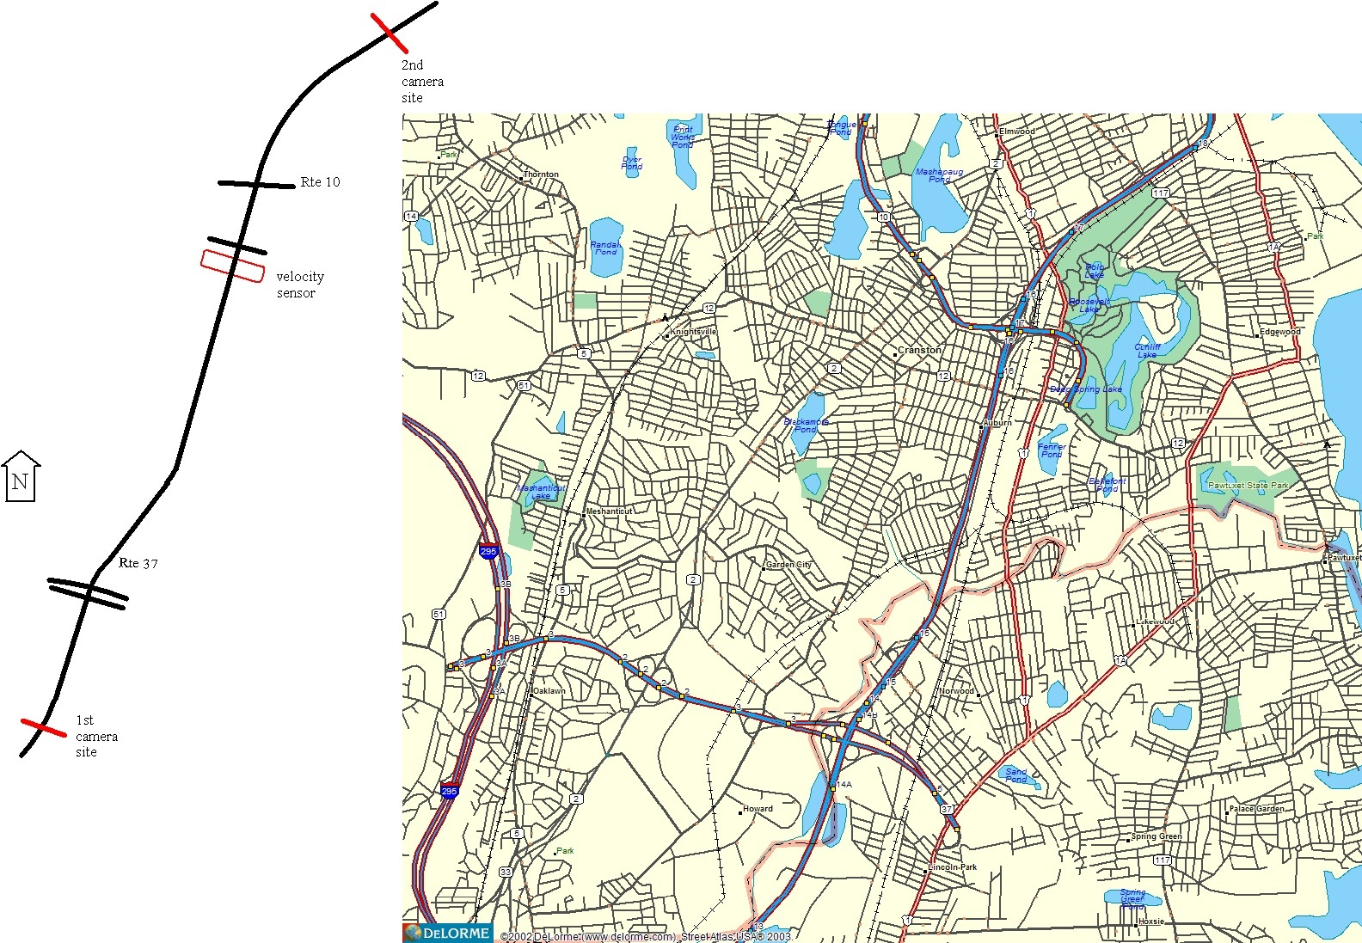

The types of data collected in this area were:

- Data collected from the loop detectors.
- License plate matching using cameras (with the help of Dr. Paul Shuldiner of UMASS Transportation Center, Amherst, MA)
- Rhode Watchers at RIDOT (Employees who volunteer to monitor the roadways during their commutes. There was also a group of RIDOT student interns who were asked to collect information during the sensor collection period).

The 4.2 mile segment between Exits 13 and 18 received the most scrutiny through our camera data collection.

Data collected from the loop detectors

In the primary study area from I-95 NB from exit 13 to exit 30 (Service avenue) to Exit 18(Broad Street), there are three sensors located in Cranston, at Branch Avenue and in Pawtucket. The sensors located in Cranston and at Branch Avenue are loop detectors (LVD), and the sensor in Pawtucket is radar (RVD). The team continuously collected data from 12th Jun 2003 to 9th July 2003 for four weeks with help from Sudhi Murthy of TrafInfo. The data that was collected from the Pawtucket sensor was erroneous and hence we have limited our data set to the Cranston sensor.

Based on first week’s sensor information (some figures and analyses are shown later), the team chose 7:30 to 9:30 AM as the peak hour traffic period, and 9:30 to 11:30 AM as a normal traffic period. Based on this, the team chose these periods as peak and off peak periods of interest for the camera (license plate matching) data collection.

License plate matching

Paul Shuldiner agreed to visit the group in June to teach the operation of the cameras and collect data for one day during study period. During this time, the team mounted two cameras at upstream and downstream locations. Travel time is calculated by taking the upstream and downstream time difference for a given vehicle. Because the frame rate of the cameras is highly regular, one can calculate accurate individual travel times. The team has chosen the times calculated in this fashion as the most accurate estimate of travel-time, more accurate than that which is calculated from the sensors and RhodeWatchers (techniques described below). As mentioned above, the team chose a 4.2mile stretch on I-95 NB from exit 13 upstream (Service Avenue) to Exit 18 downstream (Broad Street). The stretch was filmed on June 24th 2003 from 7:30 AM to 11:30 AM by mounting 2 cameras at the upstream location and 3 cameras at the down stream. The two upstream cameras captured all the vehicles traveling in the middle two lanes (i.e., lanes 2 and 3 if rightmost (slow) lane is lane 1 and leftmost (fast) lane is lane 4), and the downstream cameras captured all vehicles traveling in lanes 2, 3 and 4.

Rhode watchers (Vehicular probes)
To verifying the results and to compare the two travel-time collection techniques, the team has also collected the travel-times from the RIDOT Rhode Watchers who made trips in our study area at different times of day.

Data Formats

Loop Detectors:
In a typical loop setup for ITS surveillance, the controller (typically a Type 170 controller) collects volume, occupancy and speed from the loops. However, in this case, the loops are hooked up to a traffic counter made by Peek Traffic. This counter does not allow for collection of occupancy data. It only allows for collection of speed data in predefined (up to a max of 15) speed bins (or ranges). On the other hand, the RTMS does collect volume and occupancy. It also provides something called a "computed speed", which is a speed computed using a certain "average vehicle length". Please note that the speed coming from an RTMS is not true speed. “I understand the latest version of RTMS (model X3) allows for it; however, the RTMS currently installed by RIDOT is the older version (model X2).” Note: Italicized quote is from Sudhir Murthy of TrafInfo.

Data from these loop stations were only volume by pre-defined speed bins as shown below:

Sample data format:
00 01 0 1025 0000 0000 0000 0019 0055 0022 0003 0000
00 02 0 1025 0000 0000 0000 0001 0030 0084 0003 0002
00 03 0 1025 0000 0000 0000 0000 0018 0094 0010 0000
00 04 0 1025 0000 0000 0000 0000 0006 0034 0056 0002
00 01 0 1030 0000 0000 0000 0017 0079 0014 0000 0001
00 02 0 1030 0000 0000 0000 0001 0054 0060 0003 0000
00 03 0 1030 0000 0000 0000 0000 0038 0072 0013 0001
00 04 0 1030 0000 0000 0000 0000 0000 0017 0046 0003

In the above format, the first and third columns are not of interest. The second column gives the lane number, the fourth column gives the present time and columns 5 to 12 are speed bins with volume count aggregated based upon speeds. The speed bins employed are for vehicles traveling < 20mph, 21-30mph, 31-40mph, 41-50mph, 51-60mph, 61-70mph, 71-80mph and > 80mph.

License plate matching

The team captured the video at upstream and downstream locations, and then the license plates were matched for five minutes for every half hour, from 7:30 to 11:30 AM. The students visually compiled the plate matching results from the tape. The process normally takes 10 hours for every hour of recorded tape. The team was able to speed this up to approximately 7 hours per hour by careful spreadsheet setup. In addition the full half hour from 8:00 to 8:30AM was compiled. The travel-time was calculated by taking the difference between the time codes on the tapes for a particular vehicle. The start times of the videos at the upstream and downstream were synchronized cell phone calls between the operators for accuracy. A photo of the equipment setup in the downstream location (Service Ave. overpass) can be found in the photo at the end of the appendix of this report. Fortunately the day was sunny with very good lighting. Lighting can be one of the most important issues in accurate license plate matching techniques.

Sample Data

License plate no Upstream Downstream Travel time
AA 1:00:00 1:05:00 00:05:00

When the team was capturing the license plates they time-stamped the videos to document the exact time of the sighting of a particular license plate. The time-stamps in the tapes were accurate on the order of seconds. The students went through all the videos from the upstream for 5 minutes and downstream locations for 10 minutes each half hour intervals during the period from 7:30 to 11:30 AM. An approximate travel-time of 4 minutes was assumed for the stretch, so if the license plate numbers at the upstream location were continuously collected for the 5 minutes from 7:30 to 7:35AM, then the license plate numbers at the down stream were collected for the 10 minutes from 7:33 to 7:43:AM. This assures that slow, average and fast vehicles were all included in the travel-time data. The travel-time of a vehicle was calculated by taking the difference between upstream and downstream times. The camera data was used as a reference to the data collected from the sensor. The camera data is of high quality because our sample size of the camera data is large and is nearly close to the sensor data. Because the sensor data was collected by lane, it was possible to correlate the camera travel-time data with that of the sensor data collected during the same period.

The usefulness of the camera data is that it is highly accurate, providing a baseline for the sensor and probe data. Travel-time data is essential for the development of any travel-time reporting and prediction algorithms. This means of collecting data is invaluable to calibrate the algorithms and to verify the vehicular probe collection techniques.

Rhode Watchers (Vehicular probes):

Interns and other volunteers at RIDOT collected the travel times from Exit 13 to Exit 30 by making number of trips at different times of day. Using the travel times of their trips the team calculated and verified the travel times for the study area with travel times from other data sources (sensor and camera). The floating car technique was recommended whereby the driver of the probe tries to travel at a speed where it will pass half of the vehicles on the highway and permit half of the vehicles to pass it. Sample data format for interns is shown below.

Sample Data Collection Form:
_____________________________________________________________________

Data Collector’s Name ______________________________________

Date of data collection ____________

Designated Checkpoints Time (to nearest minute) Floating count
(+1 if pass, -1 if passed)

EXIT 8 ____:____ AM / PM
_____________

EXIT 11 ____:____ AM / PM
_____________
EXIT 16 ____:____ AM / PM
_____________
EXIT 18 ____:____ AM / PM
_____________
EXIT 23 ____:____ AM / PM
_____________
EXIT 30 ____:____ AM / PM

In general we traveled:
______ In the highest quartile of traffic speed (fastest 25%)
______ In the next to highest (50 to 75%)
______ Right in the middle!
______ In the next to lowest (25 to 50%)
______ In the lowest quartile (slowest 25%)

Our average speed for the trip was:

The traffic was: ___ heavy ____ medium ______light

The weather was (mention lighting and surface conditions, such as “cloudy with wet pavement, or sunny with dry pavement, etc.)

Incident situation:

If backups, please comments on reasons (such as highway merges/split or lighting):

Other comments:

_______________________________________________________

Using the vehicular probe data that was collected on 06/24/03 from 8:00 am to 11:30 (during the time that the camera travel-time data was collected), there was an approximate travel time of 6 minutes when compared to 5 minutes approx travel time from the camera data. Hence there is a 20% offset in the probe data. This is probably due to the fact that we did not record the camera data for Lane 1 (the slowest traffic lane). If vehicular probes are used for calibration of travel-time calculations in the future, this inaccuracy must be calculated and taken into account. In this case, a floating count was used and it was near zero.

Data Analysis:

Based on the data we have obtained from different means, we have carried out analysis in Excel by taking the loop detector data as a basis and the camera data as verification (the most accurate measurement of travel-time, thus the “ground truth”). The graphs that we have obtained for different data analyses are given below with explanations.

The above figure shows the travel time recorded from the camera in hrs: min: sec. The x-axis shows the time of the day. The time of day (by which we mean time during our collection period) was divided into two parts. One part was identified as the high volume time period and the other as low volume period. The demarcation used to distinguish between low volume and high volume periods was based on the volume patterns and volume of vehicles during that particular time of the day. This graph shows the travel time recorded during the high volume period of 8:05 am – 9:10 am. For tabulated data refer to page 30 of the report. We have used the demarcation based on the volume data from the tabulation. The demarcation was also done studied based upon the volume patterns from the sensor data shown in page 21.

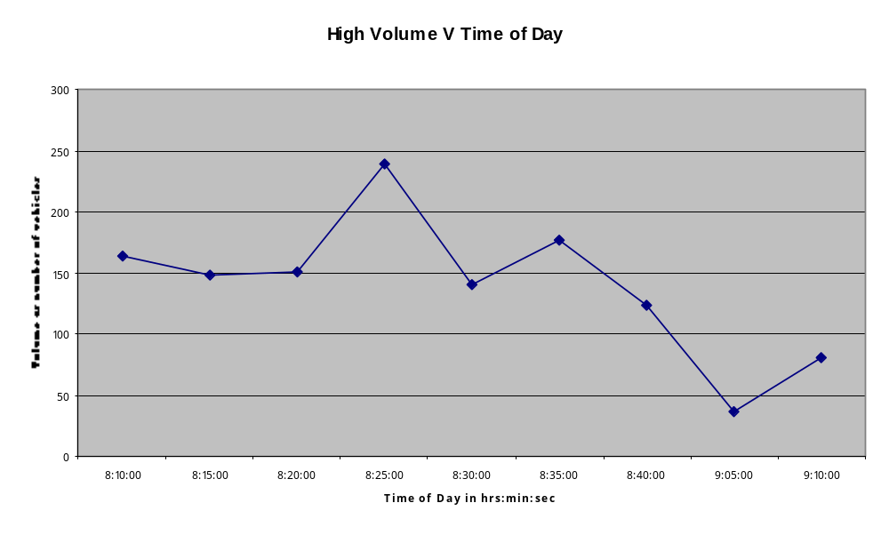

The above figure shows the total volume of the vehicles during the high volume time of the day. Each data point in the graph corresponds to the number of vehicles in a 5 minute interval We observe that the volume is at its peak in the time interval 8:15 am to 8:40am

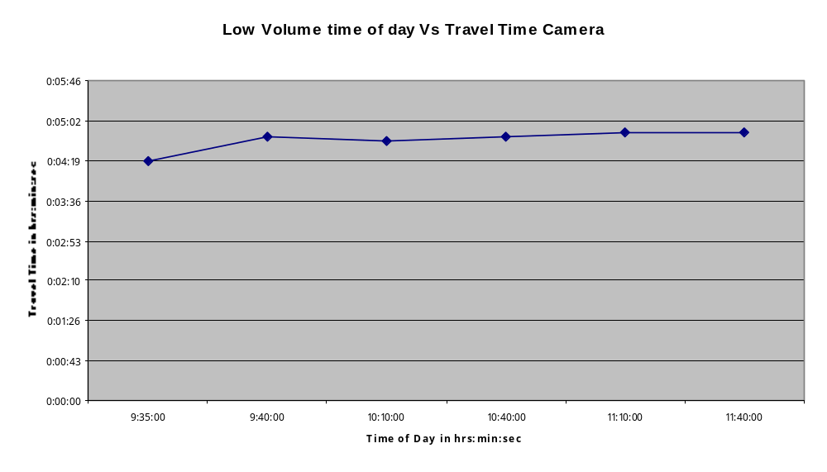
The above figure shows the recorded travel time from the camera in hrs: min: sec during the low volume time of the day. The low volume period was identified as 9:30 am- 11:30 am Even though the graph shows variability, the observed travel times do not vary significantly during the latter part of the day.

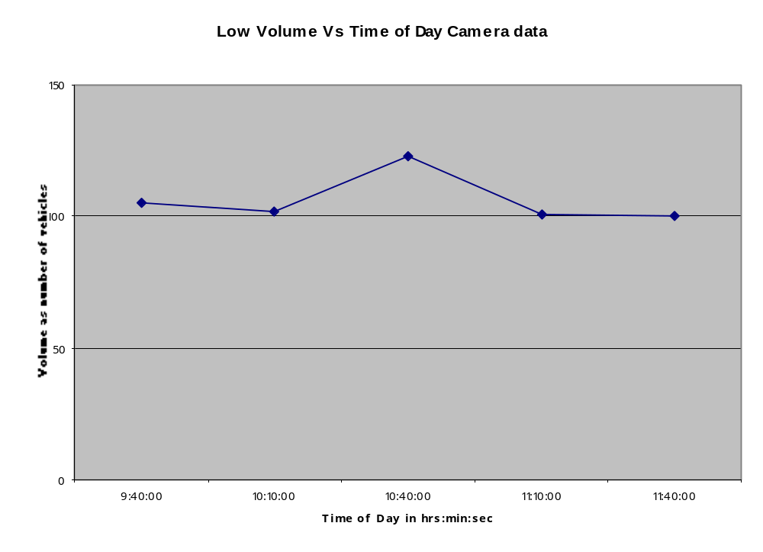
The figure shows the total volume of vehicles traveling during the low volume time of the day between 9:40 am – 11:40 am. X-axis contains the low volume time period of the day. We also observe that the volume of vehicles is fairly constant when compared to the volume of vehicles traveling during the peak travel period.

The above figure shows the travel time recorded from the camera during the time period 8:00 am to 11:40 am. Each data point in the graph corresponds to the travel time aggregated over a 5 min interval. This graph is accumulated from the previous graphs. We shall be later comparing this travel time curve with the travel time graph obtained from the sensor data.

The above figure shows the travel times recorded from the sensor data during the high volume period.
Average Speed = mph.

Travel Time = 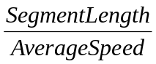
Where S_{i} represents the average speed of the ith speed bin and V_{i} is the volume (count of) vehicles recorded in the corresponding speed bin.

Observe that the travel times are fairly constant. This is because the travel times recorded at the sensor location might not reflect the actual travel-time because it is calculated from information gathered at one point in the middle of the segment. That is, there is not enough data to reflect the flow and speed of vehicles in the entire segment. The travel-time thus calculated is an estimation that is extended to the whole segment from data collected in only one spot.

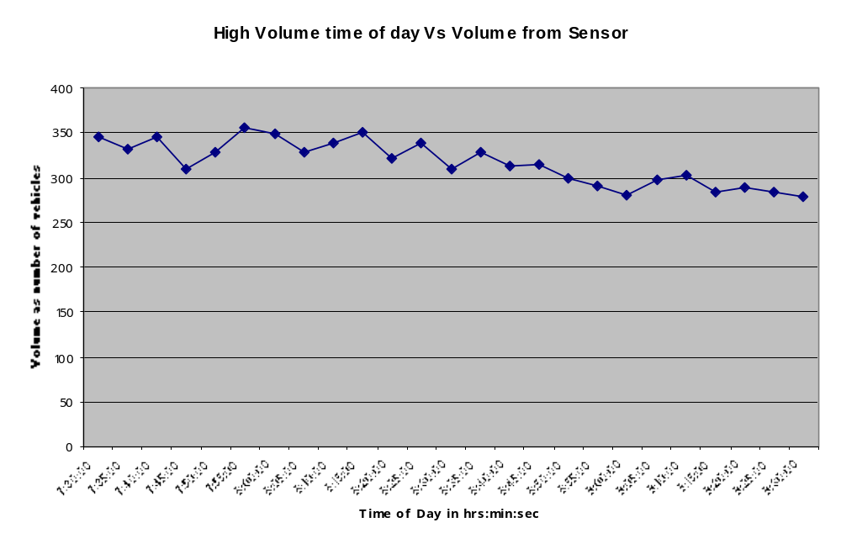

The above Figure shows the volume of vehicles traveling during the high volume time of the day. The Y-axis represents the total volume of vehicles aggregated over 5 minute intervals. The volume seen here is significantly higher when compared to the volume recorded from the camera. This is because the volume counted from the camera data consists only of the vehicles that were matched. Additional vehicles exited from the freeway during the course of the recorded time. Note that we have considered only the lanes from the sensor data for which the camera recording was performed. The lanes for which the camera data was recorded were lanes 2 & 3 for upstream, lanes 2,3, & 4 for downstream.

Above figure shows the volume of vehicles recorded during the low volume time of the day. Y-axis represents the total volume of vehicles aggregated over 5 minute intervals. This figure when compared to the previous graph is justified, as there is a considerable decrease in the volume of vehicles observed
.
Volume Patterns for Week 1 of Data Collection:

The following graphs show the traffic patterns based on volume of vehicles traveling during the entire time period of the day. The X-axis contains the time period of the day in hrs: min: sec. The Y-axis contains the total volume of vehicles in numbers, traveling in all the four lanes.

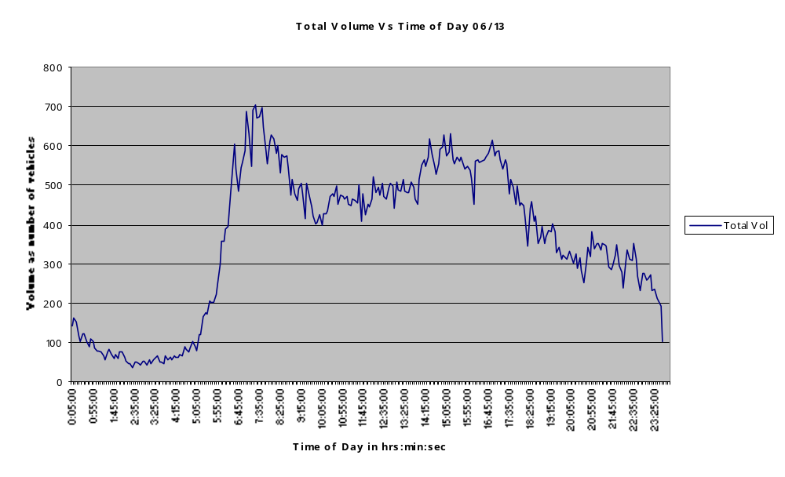

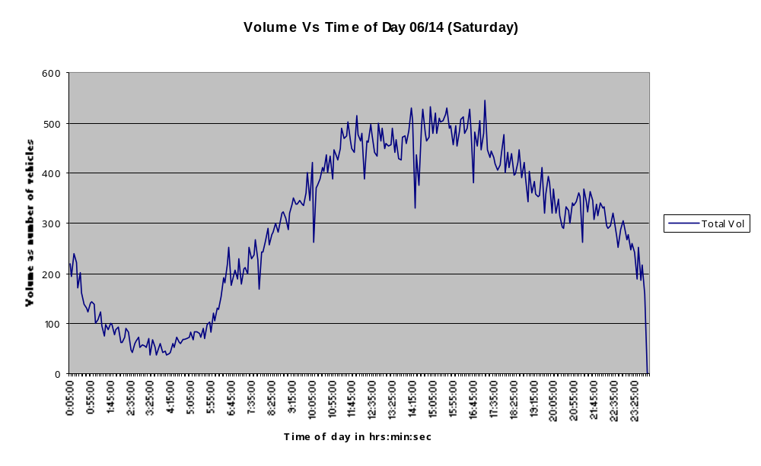
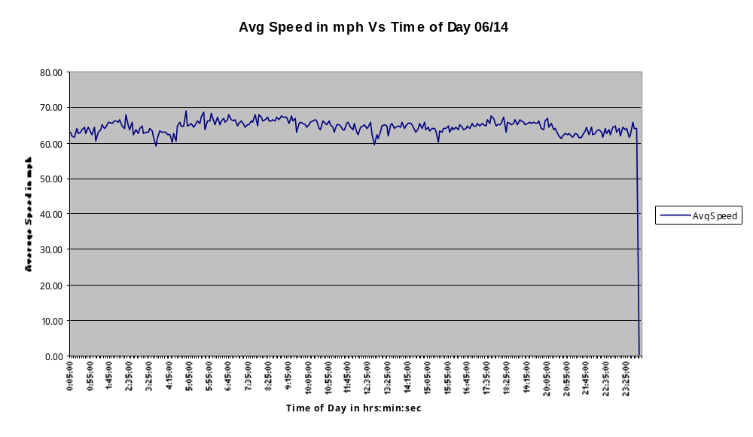
The above graph shows the speed profile of the traffic during 06/14 for the entire time period of the day. The X-axis shows the time period of the day in hrs: min: sec. The Y-axis shows the average speed of the vehicles derived from the sensor data.

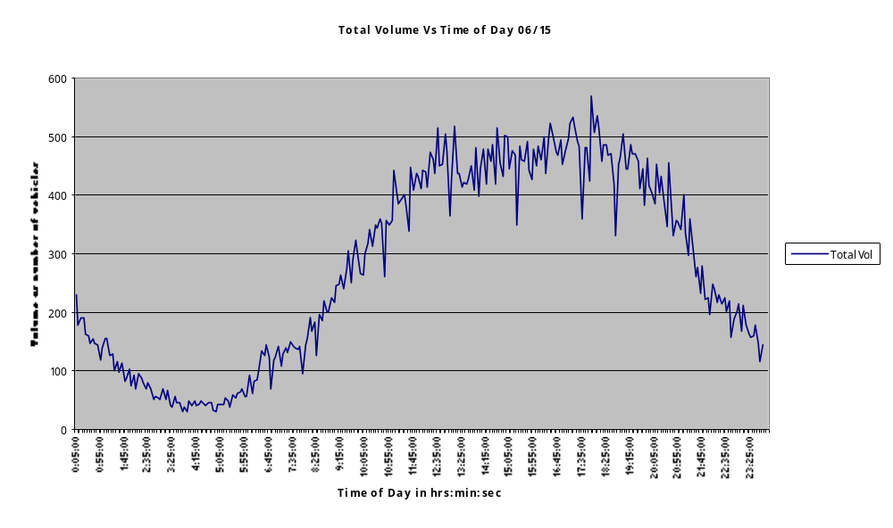
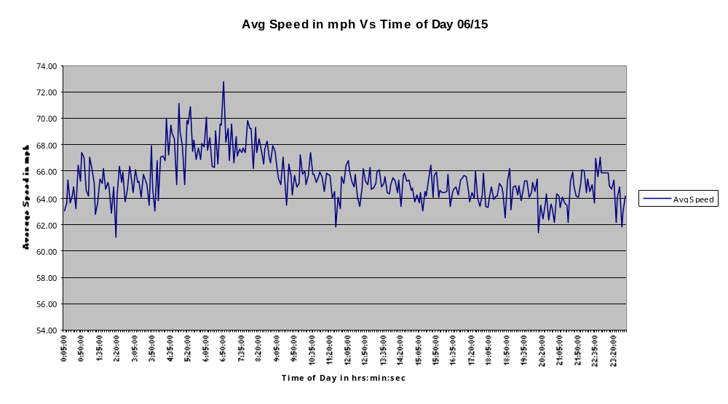The above graph shows the speed profile of the traffic during 06/15 for the entire time period of the day. The X-axis shows the time period of the day in hrs: min: sec. The Y-axis shows the average speed of the vehicles derived from the sensor data.

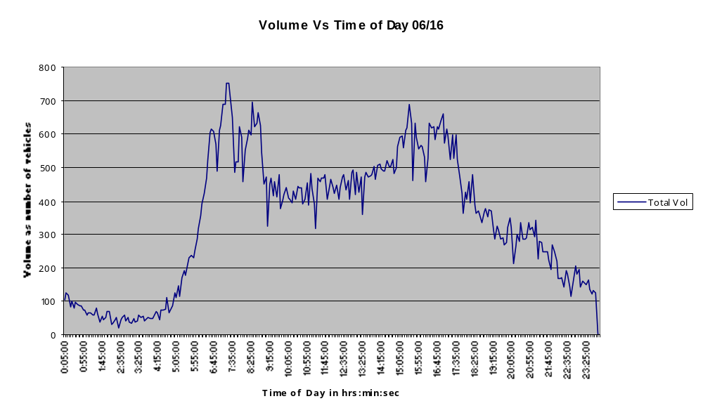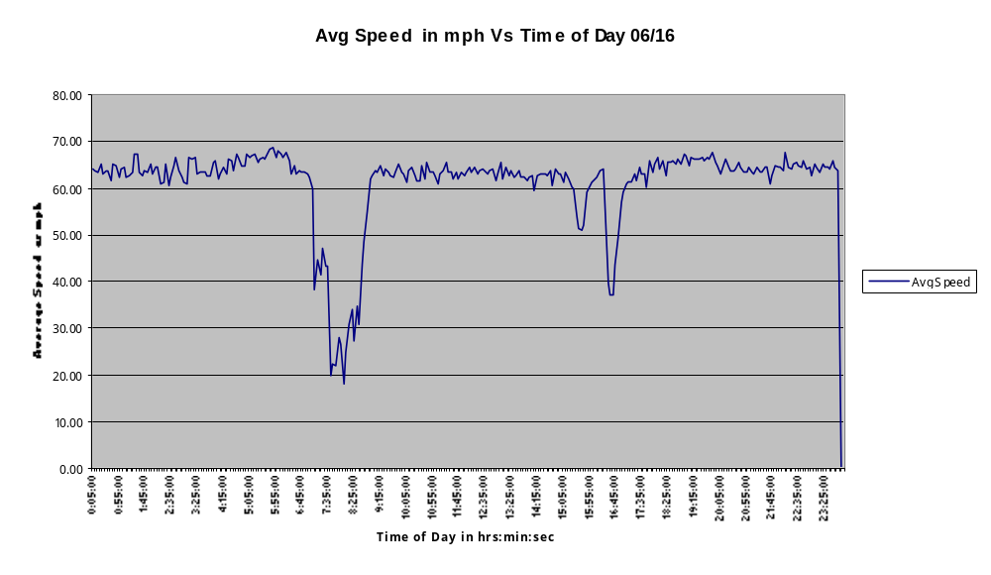

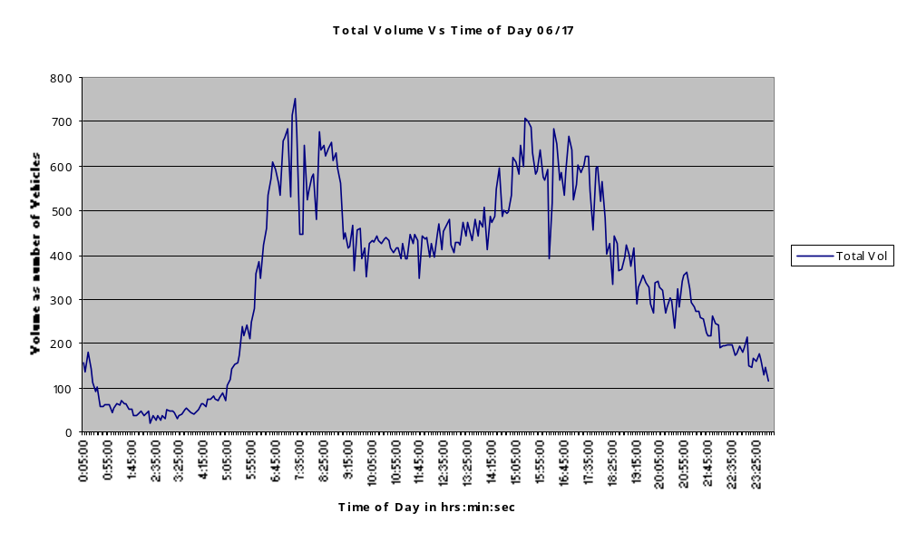

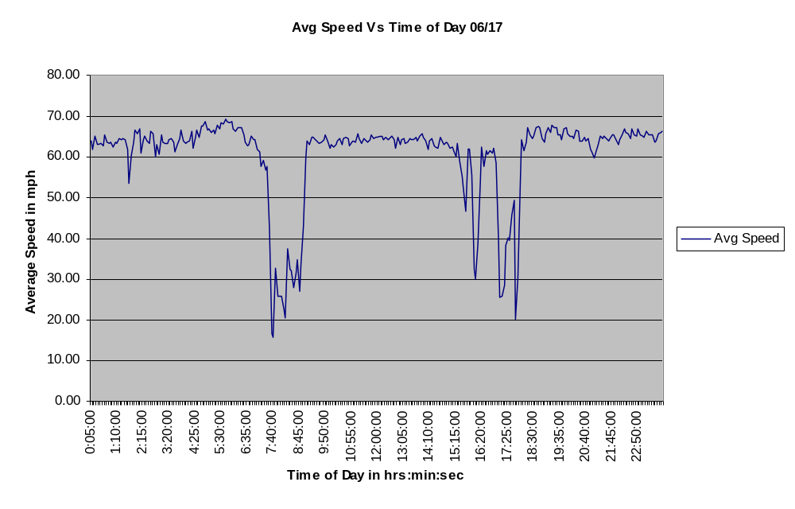
The above graph shows the speed profile of the traffic during 06/17 for the entire time period of the day. The X-axis shows the time period of the day in hrs: min: sec. The Y-axis shows the average speed of the vehicles derived from the sensor data.

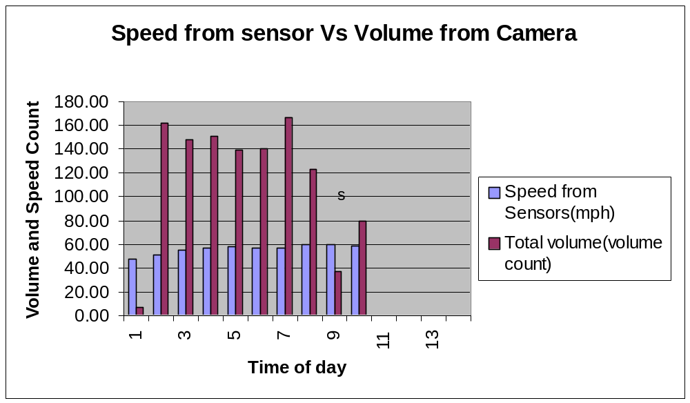The above Histogram shows total volume and speed from the camera data aggregated from the speed bins and X-axis 1 to 10 corresponds to the time interval 8:05 am to 9: 10 am. The speed bins are defined as <20, 10-20, 20-30, 30-40, 40-50, 50-60, 60-70, 70-80, >80 respectively in mph.
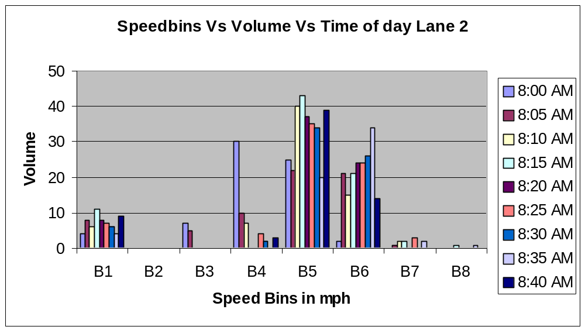

Above Histogram shows volume of vehicles traveling in the different speed bins for every 5 minute interval during the time period 8:00 am – 8:40 am. The volume of vehicles in speed bin B1 indicates the inaccuracy in the sensor readings. The Histogram also shows the majority of vehicles traveling at 50-70 mph.

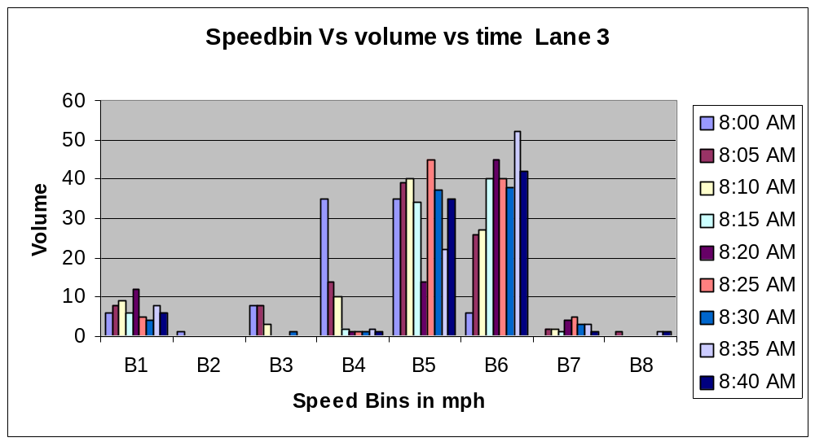

The above Histogram shows the volume of vehicles traveling in the different speed bins for every 5 minute interval during the time period 8:00 am – 8:40 am.

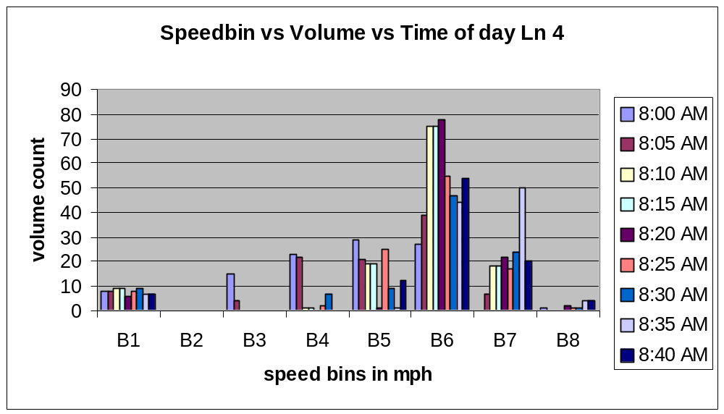

The above Histogram shows volume of vehicles traveling in the different speed bins for every 5 minute interval during the time period 8:00 am – 8:40 am.

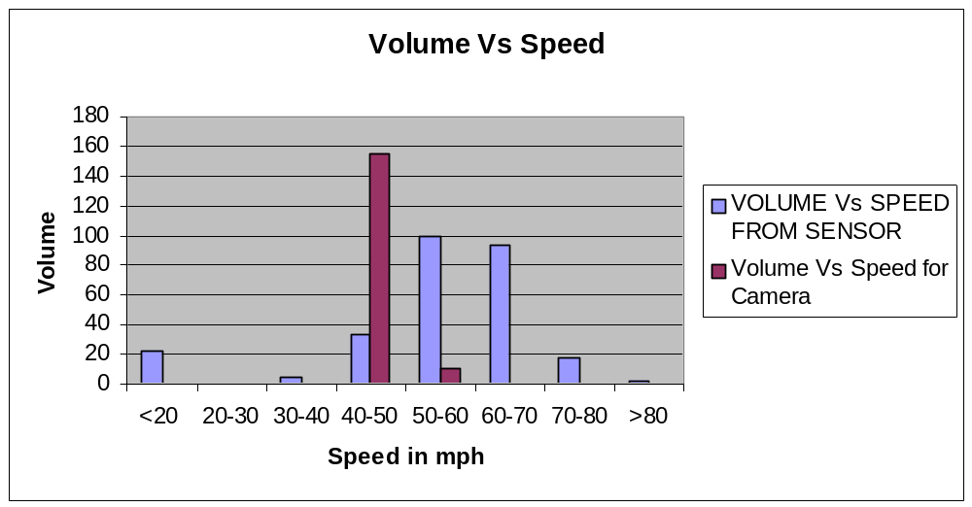

The above Histogram shows the comparison between the volume of vehicles traveling in different speed bins and the volume of vehicles calculated from the camera data in the time interval 8:05 am – 8:10 am.

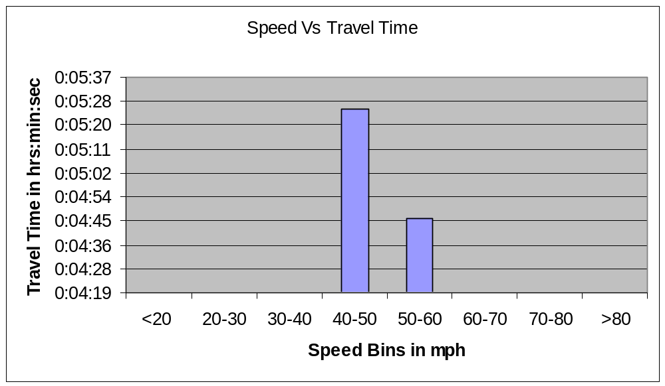

The above Histogram shows the average travel time aggregated over all the 3 lanes for vehicles traveling in speed bins 40-50 mph and 50-60 mph, which is decided from seeing the previous graphs speedbin vs Volume vs time for lanes 2, 3 and 4 shown on page 25 and page 26. This helped in deciding the speeds where the majority of people travel.

Algorithm for Estimation of Travel time:

Estimation of travel time from the sensor data:
Sensor data was collected at I-95 North in Rhode Island between Exit 13 and Exit 18. The format of the data collected is shown in the Data Formats Section above. The data contained volume counts in different speed bins for the entire day. The speed bins were < 20, 20-30, 30-40, 40-50, 50-60, 60-70, 70-80 and >80 mph respectively. The weighted average speed was calculated from the speed bins and the volume counts. The summation of volume counts multiplied by the corresponding average speed of the speed bin was found and was divided over the total volume. By performing the weighted average speed method, we come up with the average speed of all the vehicles traveling in that particular stretch of the highway. In our case, we had access to only one sensor location i.e. between Exit 13 and Exit 18.Hence we derived the travel time from the variables collected at that one sensor location. By calculating the average speeds at the sensor location, the travel time was calculated based on the length of the segment. The length of the segment between exit 13 and Exit 18 was found to be 4.12 miles. Using the data from the different sensor location we can accurately do traffic prediction. Limitation over the access to the data from the sensor at different location led to this assumption.

Time S1 S2 S3 S4 S5 S6 S7 S8
1025 V1 V2 V3 V4 V5 V6 V7 V8

Average Speed = mph.

The average speed calculated from this sensor data is used to compute the travel time. The length of the segment is found as 4.12 miles.

Travel Time =

So, travel time from the sensor is calculated in the above-mentioned method. These travel times are then compared with the travel times found using the camera in the same stretch and regression analysis is performed to correlate the relationship between the two sets of data.
The above graph shows the comparison between the travel times calculated from the sensor data and the camera data. We see an expected correlation between the two travel times. The Pink curve is the travel time calculated from the sensor and the blue curve is the travel time from the camera. The two curves have a significant scaling factor because the travel times determined from the sensor are based on spot average speeds and the travel times determined from the camera are from the space mean speeds. Also we find the curves intersecting during the time interval 9:05 am to 9:35 am. This is because the data set from the camera was found to have data of little relevance; there were fewer matched vehicles during this time period.

The above graph shows the linear regression curve between the travel time from the sensor and travel time from the camera. Here the data between the 9:05 am – 9:35 am seemed to be of little significance and did not provide a good fit to the regression. For example, the reader will notice that some points do not fit the regression well and that the value of R² is very low. As a result, we decided to eliminate the data from the camera and sensor during that particular time period and the improved regression given on the bottom of Page 31 shows a better fit.

Time Travel Time Volume
8:10:00 | 0:05:23 | 163
8:15:00 | 0:05:01 | 148
8:20:00 | 0:05:04 | 151
8:25:00 | 0:05:09 | 239
8:30:00 | 0:05:08 | 140
8:35:00 | 0:04:36 | 177
8:40:00 | 0:04:35 | 123
9:05:00 | 0:04:05 | 37
9:10:00 | 0:04:08 | 81
9:35:00 | 0:04:19 | 13
9:40:00 | 0:04:46 | 105
10:10:00 | 0:04:41 | 102
10:40:00 | 0:04:45 | 123
11:10:00 | 0:04:49 | 101
11:40:00 | 0:04:49 | 100

As shown in the table the justification for eliminating the data points can be seen above by the low volume of data during the period 8:40 am and 9:35 am. We have used sensor data from only lanes 2,3,4 in these analyses to be consistent with the data from the video’s capture (lanes 2,3,4).
The above figure shows the travel time from the sensor and the travel time from the camera after eliminating the irrelevant data during the time period 8:40 am to 9:30 am. We observe a fairly constant relation between the two observed travel times.

The above regression curve shows the improved regression by eliminating the data points with little relevance.

Flow Chart:
Import to the text file
Raw Data from the sensor
Import to the access spread sheet
Format the data to the required format (i.e., required input format to perform regression)

Data Base
Perform the regression to calculate the travel time
Display on the access spread sheet
Display Current time and Travel time to the VMS board
Raw Data
Refined Data

Software Development:

Required Software:

- Microsoft SQL Server
- Microsoft Access
- Microsoft Windows Operating System

Code description:

Step 1: Microsoft Access is loaded and opened.
Step 2: The sensor data in the text format is imported in to MS Access as “Data”
Step 3: Table is created as “ NewData” and headers are created for the table as “Lane”, “ Time”, “ b1”, “b2”, “b3”, “b4”, “b5”, “b6”, “b7”, “b8” and the relevant data is imported in to the table.
Step 4: Now the data in the “NewData” table is in the required format. Another Table is created as “NewData2”. Now the Data in all the four lanes is aggregated and querying in done based on time. Now the aggregated data i.e. combination of all lanes is in the “NewData2” table.
Step 5: New data table is created as “ NewData3”. Data is queried from “NewData2” and Total Volume is calculated and stored in “NewData3”.
Step 5: New data table is created as “NewData4”. Data is queried from “NewData3” and multiplied with the corresponding bin averages to obtain weighted average speeds. The Average speeds thus obtained are stored in “NewData4”.
Step 6: New data table is created as “Final”. Travel Time is calculated by using the length of the segment and the average speeds and stored in “Final”.
Step 7: Form is created as “Main Form” and a link created as “ Predict Travel Time” which calls the VB Script and displays the Travel time and the corresponding Time.
(Appendix contains the code for the steps mentioned above.)

Conclusion: In this project, we began to look at algorithms and techniques for the development of real-time travel time reporting and prediction systems. The project included the following:
- Development of techniques and then initial trials of data collection needed to develop the travel time algorithms. This includes the collection of speeds, volumes, and densities using stationary sensors, as well as travel times using vehicular probes and cameras for license plate matching.
- Analysis of the data collected to determine correlations between the data collected by the sensors and the more accurately measured travel times using probes and cameras.
- Development of a prototype travel time reporting algorithm.
- Initial preparations for travel time prediction algorithms.

There were many problems that we encountered in the project due to out of date or inadequate sensing devices on the highway. Similarly, we were limited to very short travel time data collection periods. The sensing equipment also has a very high level of error, with phantom vehicles traveling at very low speeds that negatively impact the data analysis process. However, this was meant to be a “quick and dirty” first attempt at developing algorithms and processes for travel time modeling. As such, it was a success in that we are able to report (see below) to RIDOT the type of equipment and data collection processes needed to develop more robust systems in the future.

Suggestions for RIDOT: In order to carry out a more accurate travel time system, we suggest that RIDOT consider the following:

- Placement of accurate sensors capable of measuring speed, volume and density at frequent intervals in all areas in which travel time prediction is desired. The more frequent, the more accurate the measurements. Something on the order of half mile intervals (as is used in congested areas in other parts of the country) would be adequate. The more congested and the more exits and entrances to the freeway, the shorter the closer sensors should be.
- Regular collection of reliable travel time information using vehicular probes, or the more accurate cameras with license plate matching capabilities. This data is needed to tune the algorithm for travel time reporting and prediction. From our preliminary project, we found that travel times can be computed somewhat reliably if we know the relationship between the sensor data and the actual travel time. The factors that determine this relationship are computed by first collecting the data, and then inferring the correlations/differences between the sensor data and the actual travel times.
- Vehicular probes are not as accurate in measuring travel time as stationary cameras with license plate matching capabilities. However, the cameras are more susceptible to lighting and other weather related conditions. Perhaps a combination of both could be used. To tune the algorithm, the vehicular probe data can first be calibrated with a few short periods of camera data collection.
- Once a travel time system is set up and tuned, it needs to be re-calibrated periodically. This means that the sensor and travel time data should be continuously collected and archived. This usually requires a greater data collection effort than is usually required for federal reporting. For example, in this project we collected data in 5 minute intervals. Some sites in the US collect data every half, one or two minutes. This would be preferable, especially in areas prone to congestion.
- RIDOT needs to review their contracts with any firms who will be equipping RI highways to determine if they are able to archive the data, and more important, use the real-time data to report and predict travel times to the traveling public.

References:

1. Heng Xiao, Hongyu Sun, Bin Ran, “The Fuzzy-Neural Network Traffic Prediction Framework with Wavelet Decomposition”, 2002.

2. Van Lint.J.W.C. , Hoogendoorn.H.J. , “Robust and adaptive travel time prediction with neural networks”, Trail Research School, Delft, 2000.

3. Jaimyoung Kwon, Benjamin Coifman, Peter Bickel, “ Day-to-Day travel time trends and travel time prediction from loop detector data”.

4. John Rice, Erik van Zwet, “ A simple and effective method for predicting travel times on freeways”, 2002.

5. Chao Chen, Alexander Skabardonis, Pravin Varaiya, “A system for displaying travel times on changeable message signs”, Transportation Research Board, 2003.

6. Karl F.Petty, Peter Bickel, Jiming Jiang, Michael Ostland, John Rice, Ya’acov Ritov, Frederic Schoenberg, “Accurate estimation of travel times from single loop detectors”.

7. Helmut T.Zwahlen, Andrew Russ, “ Evaluation of the accuracy of a real time travel time prediction system in a freeway construction work zone”, Transportation Research Board, Paper No. 02-2371, 2002.

8. Cristian E.Cortes, Riju Lavanya, Jun-Seok Oh, Jayakrishnan. R, “ A general purpose methodology for link travel time estimation using multiple point detection of traffic”, 2001.

9. Nicholas J.Garber, Lester A. Hoel, “ Traffic and Highway Engineering”, Second Edition, PWS publishing company, 1997.

10. Z. Jia, C. Chen, B. Coifman and P. Varaiya, “ The PeMS algorithms for accurate, real time estimates of g-factors and speeds from single loop detectors”, To appear in: Proceedings 4th International ITSC Conference, 2001.

Appendix

Visual Basic Code for Software Development:

Private Sub cmdRun_Click()
Dim rst As ADODB.Recordset
Dim selectRst As ADODB.Recordset
Dim icounter As Integer
Dim count As Long
Dim rawtime As Single
Dim basetime As Integer
Dim temptime1 As Single
Dim temptime2 As Single
Dim Time As Single

Set rst = New ADODB.Recordset
Set selectRst = New ADODB.Recordset

'Do
'DoCmd.Close acForm, "TravelTimeDisplay"
'delete the temporary table every time the form is loaded
rst.Open "NewData", CurrentProject.Connection, adOpenStatic, adLockOptimistic
If rst.RecordCount > 0 Then
rst. MoveFirst
Do
rst.Delete
rst.MoveNext
Loop Until rst.EOF
End If

Step 2:

'Get the required data into temporary table
SelectRst. Source = "SELECT ([Field2]) AS Lane, ([Field4]) AS [Time], " & _
"([Field5]) AS b1, ([Field6]) AS b2, ([Field7]) AS b3, ([Field8]) AS b4, " & _
"([Field9]) AS b5, ([Field10]) AS b6, ([Field11]) AS b7, ([Field12]) " & _
"AS b8 " & _
"FROM Data " & _
"WHERE Field4>=1 "

SelectRst. Open, CurrentProject.Connection, adOpenStatic, adLockOptimistic
If selectRst.RecordCount > 0 Then
For icounter = 1 To selectRst.RecordCount
rst.AddNew
selectRst.AbsolutePosition = icounter
rst. Fields(0).Value = selectRst. Fields(0).Value
rst.Fields(1).Value = selectRst.Fields(1).Value
rst.Fields(2).Value = selectRst.Fields(2).Value
rst.Fields(3).Value = selectRst.Fields(3).Value
rst.Fields(4).Value = selectRst.Fields(4).Value
rst.Fields(5).Value = selectRst.Fields(5).Value
rst.Fields(6).Value = selectRst.Fields(6).Value
rst.Fields(7).Value = selectRst.Fields(7).Value
rst.Fields(8).Value = selectRst.Fields(8).Value
rst.Fields(9).Value = selectRst.Fields(9).Value
rst.Update
Next icounter
End If
rst.Close
selectRst.Close

Step 3:

rst.Open "NewData2", CurrentProject.Connection, adOpenStatic, adLockOptimistic
If rst.RecordCount > 0 Then
rst.MoveFirst
Do
rst.Delete
rst.MoveNext
Loop Until rst.EOF
End If

selectRst.Source = "SELECT NewData.Time, Sum(([NewData].[b1])) AS b1, " & _
"Sum(([NewData].[b2])) AS b2, Sum(([NewData].[b3])) AS b3, Sum(([NewData].[b4])) " & _
"AS b4, Sum(([NewData].[b5])) AS b5, Sum(([NewData].[b6])) AS b6, " & _
"Sum(([NewData].[b7])) AS b7, Sum(([NewData].[b8])) AS b8 " & _
"FROM NewData " & _
"GROUP BY NewData.Time " & _
"ORDER BY NewData.Time "

selectRst.Open , CurrentProject.Connection, adOpenStatic, adLockOptimistic
If selectRst.RecordCount > 0 Then
For icounter = 1 To selectRst.RecordCount
rst.AddNew
selectRst.AbsolutePosition = icounter
rst.Fields(0).Value = selectRst.Fields(0).Value
rst.Fields(1).Value = selectRst.Fields(1).Value
rst.Fields(2).Value = selectRst.Fields(2).Value
rst.Fields(3).Value = selectRst.Fields(3).Value
rst.Fields(4).Value = selectRst.Fields(4).Value
rst.Fields(5).Value = selectRst.Fields(5).Value
rst.Fields(6).Value = selectRst.Fields(6).Value
rst.Fields(7).Value = selectRst.Fields(7).Value
rst.Fields(8).Value = selectRst.Fields(8).Value
rst.Update
Next icounter
End If

rst.Close
selectRst.Close

Step 4:

rst.Open "NewData3", CurrentProject.Connection, adOpenStatic, adLockOptimistic
If rst.RecordCount > 0 Then
rst.MoveFirst
Do
rst.Delete
rst.MoveNext
Loop Until rst.EOF
End If

selectRst.Source = "SELECT NewData2.*, " & _
"([NewData2].[b1]+[NewData2].[b2]+[NewData2].[b3]+[NewData2].[b4]+[NewData2].[b5] " & _
"+[NewData2].[b6]+[NewData2].[b7]+[NewData2].[b8]) AS Total_Volume " & _
"FROM NewData2 "

selectRst.Open , CurrentProject.Connection, adOpenStatic, adLockOptimistic
If selectRst.RecordCount > 0 Then
For icounter = 1 To selectRst.RecordCount
rst.AddNew
selectRst.AbsolutePosition = icounter
rst.Fields(0).Value = selectRst.Fields(0).Value
rst.Fields(1).Value = selectRst.Fields(1).Value
rst.Fields(2).Value = selectRst.Fields(2).Value
rst.Fields(3).Value = selectRst.Fields(3).Value
rst.Fields(4).Value = selectRst.Fields(4).Value
rst.Fields(5).Value = selectRst.Fields(5).Value
rst.Fields(6).Value = selectRst.Fields(6).Value
rst.Fields(7).Value = selectRst.Fields(7).Value
rst.Fields(8).Value = selectRst.Fields(8).Value
rst.Fields(9).Value = selectRst.Fields(9).Value
rst.Update
Next icounter
End If

rst.Close
selectRst.Close

Step 5:

rst.Open "NewData4", CurrentProject.Connection, adOpenStatic, adLockOptimistic
If rst.RecordCount > 0 Then
rst.MoveFirst
Do
rst.Delete
rst.MoveNext
Loop Until rst.EOF
End If

selectRst.Source = "SELECT NewData3.*, ((([b1]*15)+([b2]*25)+([b3]*35)+([b4]*45)+ " & _
"([b5]*55)+([b6]*65)+([b7]*75)+([b8]*85))/[Total_Volume]) AS Avg_Speed " & _
"FROM NewData3 "

selectRst.Open , CurrentProject.Connection, adOpenStatic, adLockOptimistic
If selectRst.RecordCount > 0 Then
For icounter = 1 To selectRst.RecordCount
rst.AddNew
selectRst.AbsolutePosition = icounter
rst.Fields(0).Value = selectRst.Fields(0).Value
rst.Fields(1).Value = selectRst.Fields(1).Value
rst.Fields(2).Value = selectRst.Fields(2).Value
rst.Fields(3).Value = selectRst.Fields(3).Value
rst.Fields(4).Value = selectRst.Fields(4).Value
rst.Fields(5).Value = selectRst.Fields(5).Value
rst.Fields(6).Value = selectRst.Fields(6).Value
rst.Fields(7).Value = selectRst.Fields(7).Value
rst.Fields(8).Value = selectRst.Fields(8).Value
rst.Fields(9).Value = selectRst.Fields(9).Value
rst.Fields(10).Value = selectRst.Fields(10).Value
rst.Update
Next icounter
End If

rst.Close
selectRst.Close

Step 6:

rst.Open "Final", CurrentProject.Connection, adOpenStatic, adLockOptimistic
If rst.RecordCount > 0 Then
rst.MoveFirst
Do
rst.Delete
rst.MoveNext
Loop Until rst.EOF
End If

selectRst.Source = "SELECT NewData4.*, ((4.12*60)/[Avg_Speed]) AS " & _
"Travel_Time " & _
"FROM NewData4 " & _
"ORDER BY [Time] "

selectRst.Open , CurrentProject.Connection, adOpenStatic, adLockOptimistic
If selectRst.RecordCount > 0 Then
For icounter = 1 To selectRst.RecordCount
rst.AddNew
selectRst.AbsolutePosition = icounter
rst.Fields(0).Value = Format(selectRst.Fields(0).Value, "&&:&&")
rst.Fields(1).Value = selectRst.Fields(1).Value
rst.Fields(2).Value = selectRst.Fields(2).Value
rst.Fields(3).Value = selectRst.Fields(3).Value
rst.Fields(4).Value = selectRst.Fields(4).Value
rst.Fields(5).Value = selectRst.Fields(5).Value
rst.Fields(6).Value = selectRst.Fields(6).Value
rst.Fields(7).Value = selectRst.Fields(7).Value
rst.Fields(8).Value = selectRst.Fields(8).Value
rst.Fields(9).Value = selectRst.Fields(9).Value
rst.Fields(10).Value = selectRst.Fields(10).Value
rawtime = selectRst.Fields(11).Value
basetime = Int(rawtime)
temptime1 = rawtime - basetime
temptime2 = temptime1 - 0.6
If (temptime2 < 0) Then
Time = rawtime
Else
basetime = basetime + 1
Time = basetime + temptime2
End If
rst.Fields(11).Value = Time
rst.Update
rawtime = 0
basetime = 0
temptime1 = 0
temptime2 = 0
Time = 0
Next icounter
End If

rst.Close
selectRst.Close

Step 7:

DoCmd.Close acForm, "MainForm"
DoCmd.OpenForm "TravelTimeDisplay"

'For count = 1 To 90000000
'Next count
'Loop

End Sub

Photo of Camera Setup at Service Ave

